Responsible sourcing instruction template

The template has been developed to help you meet the requirements of Articles 8–15 of the Corporate Sustainability Due Diligence Directive, as they relate to the supply chain. To the greatest extent possible it is aligned with the UN Guiding Principles on Business and Human Rights and the OECD Due Diligence Guidance for Responsible Business Conduct, including its six steps. Major differences are explained in comments. This means that if your company is not in scope of the Directive, the template can still support your efforts to strengthen supply chain due diligence.
A few comments on the template:
- Unlike Articles 10 and 11 of the Directive, this template does not distinguish between “prevention” and “corrective” action plans. Companies usually include both actual and potential adverse impacts in their risk assessments, and they typically address both in a single action plan. If an actual adverse impact arises during a contract, new measures to address it should be added to the existing action plan or be included in an enhanced action plan.
- Both regular and enhanced action plans are referenced, consistent with Articles 10 and 11. However, enhanced action plans are reserved for severe adverse impacts. The Directive seems to assume that companies as a rule enter relationships when all impacts have been prevented, mitigated, or brought to an end, because enhanced action plans are meant to apply where adverse impacts still exist. In practice, as any audit report shows, companies routinely enter business relationships where adverse impacts exist. Enhanced action plans are therefore reserved for severe impacts, not every unresolved impact.
Footnotes provide guidance for your understanding—delete them.
Note that according to the Corporate Sustainability Due Diligence Directive, you shall develop this instruction in consultation with your employees and their representatives.

Responsible Sourcing

This instruction sets rules for [company]’s responsible sourcing practices, covering human rights, environmental, and business ethics due diligence in the supply chain.
It specifies sourcing-related roles, responsibilities, and processes, and is complemented by [company]’s [due diligence instruction] and [complaints procedure].
Where suppliers have been engaged outside of a formal procurement process (e.g. long-standing relationships), equivalent due diligence measures shall be introduced retroactively.
For illustrative purposes, the instruction follows the OECD Due Diligence process:
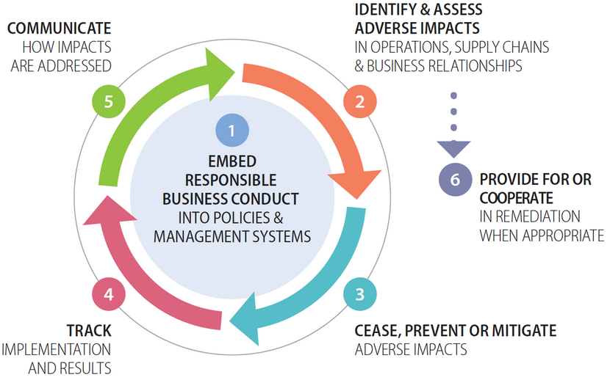

Target Groups
Basic knowledge
The following groups shall have basic knowledge of this instruction (know it exists, the main purpose of it, and where to find it):
- Board of Directors (oversight role)
- CEO [and Executive Management Team]
- Heads of Staff Functions
- [Heads of Business Areas / Business Units]
Thorough knowledge
The following groups shall have thorough knowledge of this instruction (know the details, roles, and responsibilities) and comply with the roles and responsibilities described herein:
- Head of Procurement
- Category Managers
- Procurement Managers
- Buyers
- Sustainability Managers responsible for supply chain due diligence
- Legal staff drafting and reviewing contract clauses and remediation
- Coordinators supporting supplier onboarding and monitoring

Terms
Term | Meaning in this instruction
Due diligence | Ongoing process through which [company] identifies, prevents, mitigates, tracks, and communicates on actual and potential adverse impacts in its operations and value chain.
Prioritised purchasing category | Purchasing categories with the highest risk of severe adverse impacts [and significant spend], identified for focused due diligence.
Adverse impacts | Negative impacts on people, the environment and society in the supply chain.
Supply chain mapping | A mapping of the material flows and likely countries of final manufacturing, component manufacturing, smelting and refining, and raw material extraction (goods).
Labour supply chain mapping | A mapping of the subcontractors, labour providers, recruitment agencies, and the countries from which workers are sourced (works/services).
Supplier | Any business partner providing goods, works, or services to [company], including suppliers of materials, components, and final products, contractors, service providers, transport and logistics companies, recyclers, and other entities engaged through procurement processes.
Affected stakeholder | Individual, group, or community that is or may be adversely affected by [company]’s value chain.
Meaningful stakeholder engagement | Engagement with affected stakeholders that is based on two-way communication, conducted in good faith, and responsive and ongoing.
Scale, scope, and irremediability | Framework to determine the severity of an adverse impact.
Causation, contribution, linkage | Framework to determine company’s involvement in an adverse impact.
Action plan | Internal plan that sets out measures to cease, prevent, or mitigate adverse impacts. In this instruction, action plan covers both preventive and corrective action plans under the Corporate Sustainability Due Diligence Directive (Articles 10 and 11).
Enhanced action plan | Strengthened set of measures developed when a severe adverse impact cannot be addressed by a standard action plan.
Leverage | [Company’s] ability to influence a supplier to cease, prevent or mitigate adverse impacts.
Pre-qualification | Supplier screening process before contracting, based on due diligence and prioritised adverse impacts.
Contractual assurances | Legally binding supplier commitments to comply with [company]’s [Supplier Code of Conduct] and due diligence requirements, and to cascade requirements to sub-suppliers.
Third-party verification (audit) | Independent assessment of supplier practices informed by meaningful stakeholder engagements, used to verify compliance and identify adverse impacts.
Shared responsibility | Principle that buyers and suppliers jointly contribute to managing risks, rather than shifting responsibility upstream.
Responsible purchasing practices | Purchasing practices that support positive human rights and environmental outcomes, e.g., fair prices, reasonable deadlines, and adequate assistance.
Complaints procedure | Process allowing external stakeholders to raise human rights or environmental concerns.
Remediation | Process and measures to restore or compensate affected stakeholders when harm has occurred.

1. Embed Responsible Business Conduct
1.1 Responsibilities
[Head of Procurement] is responsible for appointing one or more persons in management positions ([Category Managers]) as responsible for supply chain due diligence.
[Category Managers] are responsible for assigning responsibility for implementing supply chain due diligence to those employees whose decisions are most likely to increase or decrease risks of adverse impacts, specifically:
- [Procurement Managers
- Buyers
- Contract Managers
- Sustainability Managers
- Coordinators].
1.2 Training
[Head of Procurement] is responsible for ensuring that persons in management positions and those employees whose decisions are most likely to increase or decrease risks of adverse impacts are trained in supply chain due diligence.
1.3 Contract clauses
[Staff Function Legal], in consultation with [Category Managers, Procurement Managers, Contract Managers and Sustainability Managers], shall ensure that due diligence contract clauses are:
- based on the principles of shared responsibility, responsible purchasing practices and remediation first
- adaptable depending on supplier size, capacity and risk
- accompanied by appropriate methods to verify compliance.
Due diligence contract clauses shall also include commitments to:
- cascade the requirements
- disclose suppliers and locations, where needed
- comply with action plans, where needed.
2. Identify and Assess Adverse Impacts
2.1 Prioritised purchasing categories
[Category Managers], in consultation with [Procurement Managers, Contract Managers and Sustainability Managers], shall [every 12/36 months] identify prioritised purchasing categories based on where adverse impacts are most likely to occur and be most severe[, and significant spend]. The assessment shall cover the entire supply chain’s context.
2.2 Supply chain mappings
[Sustainability Managers], in consultation with [Procurement Managers, Contract Managers and Coordinators], shall map the material flows and likely countries of final manufacturing, component manufacturing, smelting and refining, and raw material extraction of [prioritised purchasing categories/high-risk goods in prioritised purchasing categories].
[Sustainability Managers], in consultation with [Procurement Managers, Contract Managers and Coordinators], shall map the labour supply chain of [prioritised purchasing categories/high-risk works and services in prioritised purchasing categories], including subcontractors, labour providers, recruitment agencies, and the countries from which workers are sourced.
[Sustainability Managers] shall regularly update the supply chain mappings based on confirmed supplier and location data gathered through disclosures and supplier engagements, see 3.2.5 and 3.2.7.
[[Sustainability Managers, in consultation with [Category Managers and Coordinators] shall disclose confirmed supplier and location data on Open Supply Hub.]
2.3 Risk assessments
[Sustainability Managers] shall regularly identify and assess actual and potential adverse impacts in [prioritised purchasing categories/high-risk goods, works and services in prioritised purchasing categories], taking into account geographic risks, sector risks and product risks.
Geographic risks | Geographic risks are conditions in a particular country which may make sector risks more likely. Geographic risk factors can generally be classified as those related to the regulatory framework (e.g. alignment with international conventions), governance (e.g. strength of inspectorates, rule of law, level of corruption), socio-economic context (e.g. poverty and education rates, vulnerability and discrimination of specific populations) and political context (e.g. presence of conflict).
Sector risks | Sector risks are risks that are prevalent within a sector globally as a result of the characteristics of the sector, its activities, its products and production processes. For example, the extractive sector is often associated with risks related to a large environmental footprint and impacts on local communities. In the garment and footwear sector, risks associated with respect for trade union rights, occupational health and safety and low wages are prevalent, amongst others.
Product risks | Product risks are risks related to inputs or production processes used in the development or use of specific products. For example, garment products with beading or embroidery hold a higher risk of informal employment and precarious work and phones and computers may contain components that are at risk of being mined from conflict areas.

2.3.1 Engagements and sources
While identifying and assessing adverse impacts, [Sustainability Managers] shall meaningfully engage with affected stakeholders or their representatives and consider information raised through complaints procedures.
To fulfil this requirement, [Sustainability Managers] may rely on information in independent third-party verifications (audits) commissioned before entering business relationship or as part of verifying compliance (see 3.2.4 and 4.2.3)—or requested from suppliers if commissioned by other parties—provided they are based on meaningful engagements with affected stakeholders or their representatives.
Where direct engagement is not feasible, risk assessments shall be informed by credible resources and recognised experts.
[Sustainability Managers] shall also prioritise obtaining information directly from business partners where adverse impacts are most likely to occur—through supplier engagements on risks, self-assessments and third-party verifications (audits) (see 3.2.7, 4.2.2 and 4.2.3).
2.3.2 Particularly vulnerable groups
While identifying and assessing adverse impacts, [Sustainability Managers] shall pay special attention to vulnerable groups, including at a minimum women, children, migrant workers, minorities, persons with disabilities, and indigenous peoples.
2.3.3 Severity and likelihood
While identifying and assessing adverse impacts, [Sustainability Managers] shall prioritise the identified adverse impacts based on severity and likelihood. Severity shall be judged by the adverse impacts’:
Scale | The gravity of the adverse impact.
Scope | The reach of the adverse impact, for example the number of individuals that are or will be affected or the extent of environmental damage.
Irremediable character | Any limits on the ability to restore the individuals or environment affected to a situation equivalent to their situation before the adverse impact.

2.3.4 Involvement, tier and leverage
While identifying and assessing adverse impacts, [Sustainability Managers] shall determine:
- [Company’s] involvement in the adverse impact (causation, contribution, linkage).
- In what tier of the supply chain the adverse impact (may) occur(s).
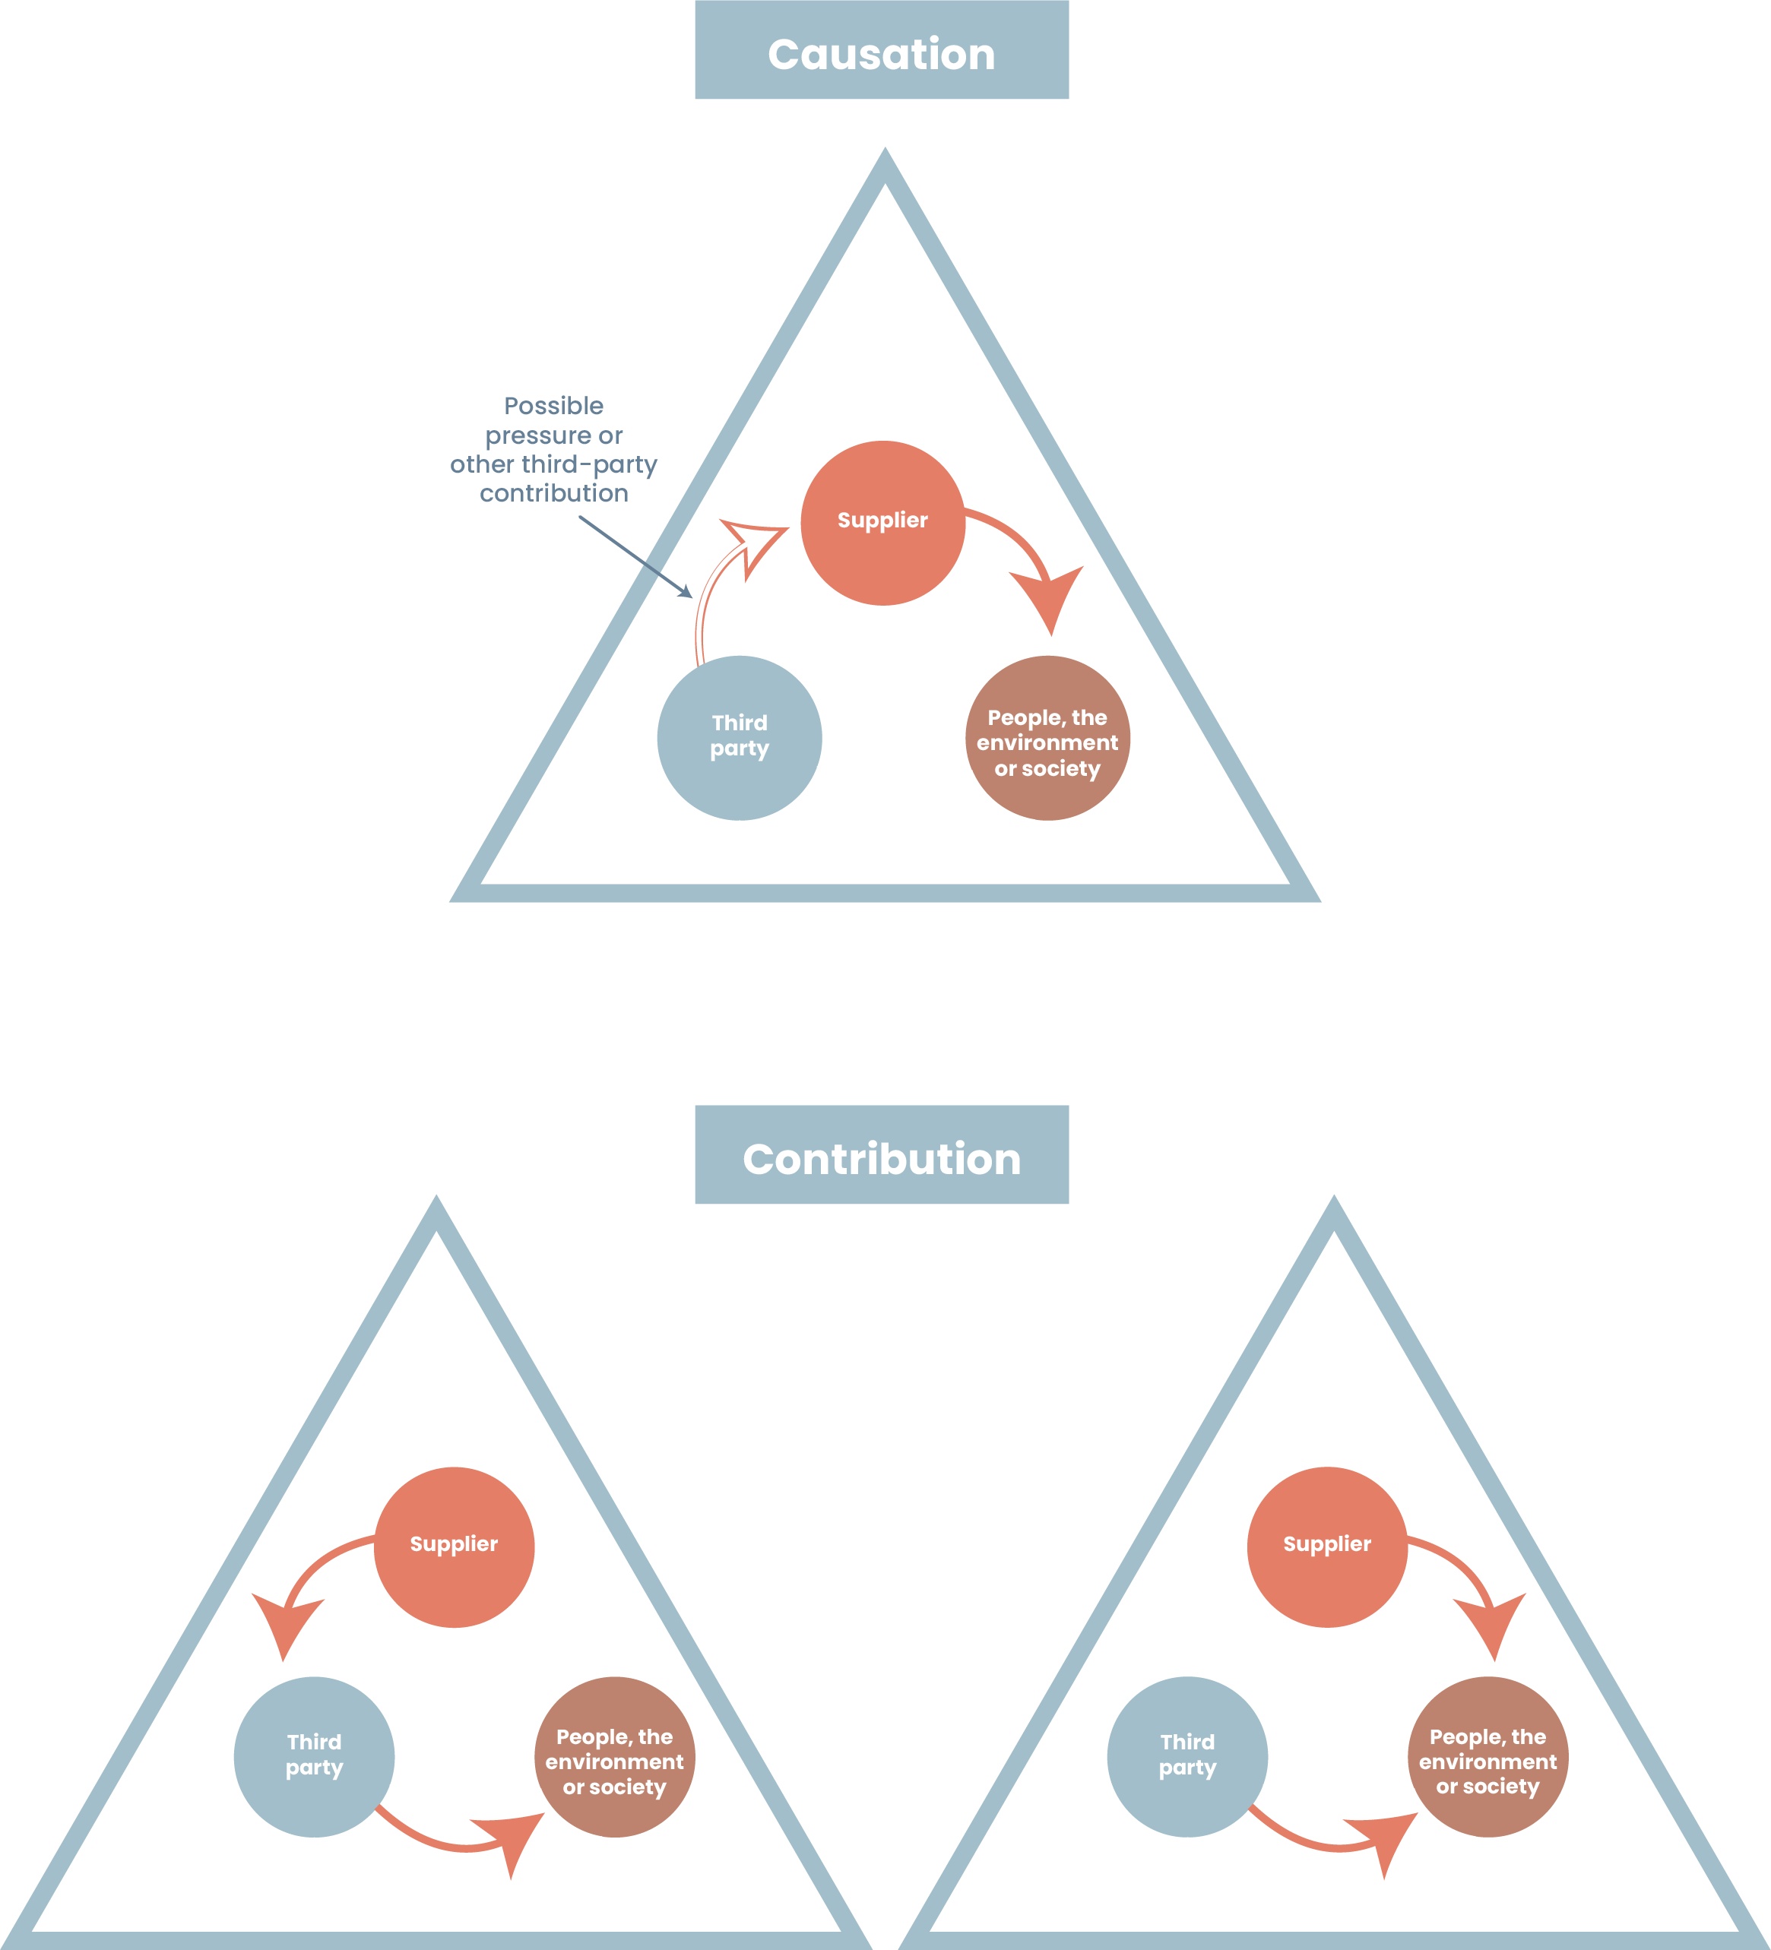
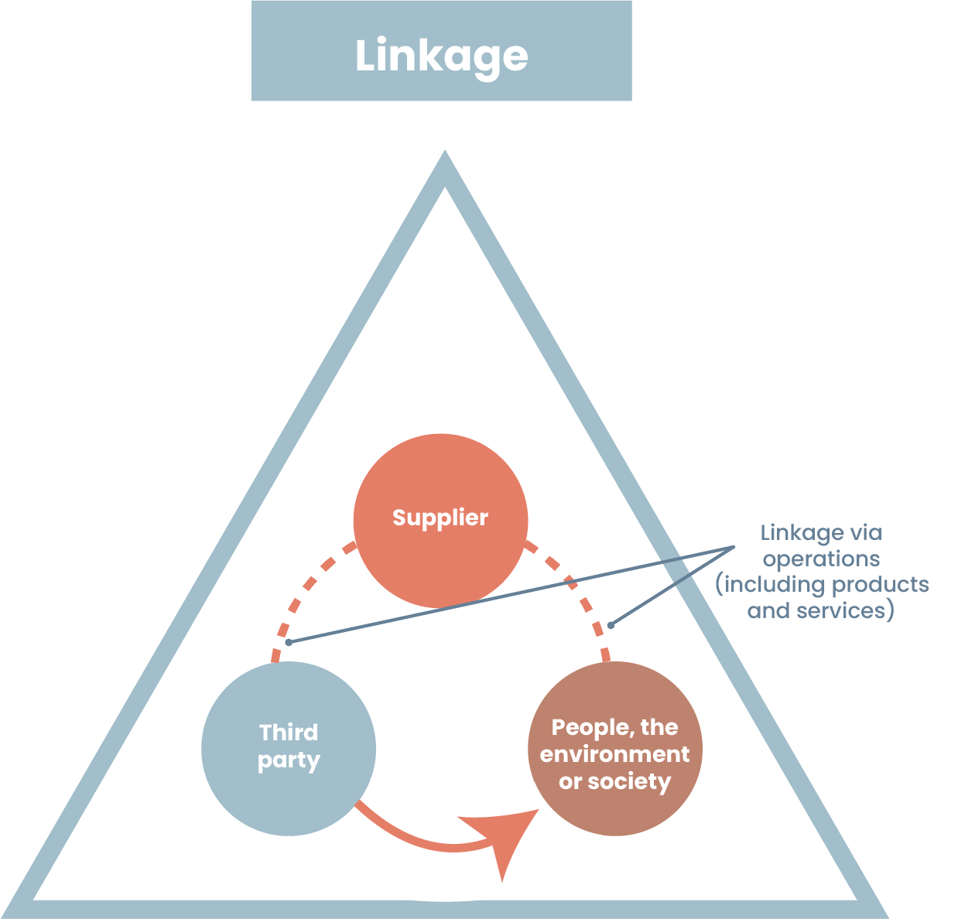
- [Company’s] ability to influence the supplier that (may) cause(s) or contribute(s) to the adverse impact (leverage).
2.3.5 Monitoring of adverse impacts and updates of risk assessments
[Sustainability Managers] shall monitor adverse impacts in the supply chains of prioritised purchasing categories, through media, civil society, trade unions, academia etc., and update risk assessments without undue delay after significant changes occur or when new risks are identified.
3. Cease, Prevent and Mitigate
[Procurement Managers/Contract Managers], in consultation with [Sustainability Managers], shall immediately cease activities that are causing or contributing to actual adverse impacts, including purchasing practices (see 3.2.1)
Where [company] is one of several entities contributing to an adverse impact, [Procurement Managers/Contract Managers], in consultation with [Sustainability Managers], shall engage with other involved entities to cease, prevent or mitigate the impacts.
Where [company] is contributing to an adverse impact caused by another entity, [Procurement Managers/Contract Managers], in consultation with [Sustainability Managers], shall take steps to cease, prevent, or mitigate [company’s] contribution, and use leverage to mitigate any remaining impact.
3.1 Action plans
[Category Managers], in consultation with [Procurement Managers, Contract Managers and Sustainability Managers], shall develop and implement action plans for prioritised purchasing categories, with:
- Appropriate measures (see 3.2) depending on [company]’s involvement in the adverse impact (causation, contribution or linkage), in what tier the adverse impacts (may) occur(s), and [company]’s leverage.
- Clearly defined responsibilities and reasonable timelines.
- Qualitative and quantitative indicators to track progress and improvement.
[Sustainability Managers] shall meaningfully engage with affected stakeholders or their representatives on the action plans, including indicators. Where direct engagement is not feasible, action plans shall be informed by credible resources and recognised experts.
3.2 Appropriate measures
3.2.1 Responsible purchasing practices
[Category Managers], in consultation with [Procurement Managers, Buyers, Contract Managers, Sustainability Managers and Coordinators], shall identify and address barriers in [company]’s own purchasing practices and commercial terms that may hinder suppliers’ ability to comply with [company]’s [Supplier Code of Conduct] or implement due diligence. Particular attention shall be paid to how [company]’s purchasing practices may contribute to adverse impacts, see examples below:
Time pressure | Excessive overtime
Price pressure | Unfair wages
Last-minute order changes (e.g. increases in quantity or design changes) | Excessive overtime, insecure employment
Changes to payment terms during the contract period | Unfair wages
Take-it-or-leave-it contracts that hinder supplier compliance | Deficiencies in health and safety, unfair wages, excessive overtime, insecure employment
Insufficient weighting of sustainability in evaluations | All commitments
Lack of remedy for contributions to adverse impacts | All commitments
Termination of contracts without responsible exits | All commitments

3.2.2 Screenings
[Sustainability Managers] shall screen all suppliers against sanctions, politically exposed persons (PEPs), and adverse media before entering business relationships.
3.2.3 Pre-qualifications and award criteria
[Procurement Managers/Buyers], in consultation with [Sustainability Managers], shall pre-qualify suppliers in prioritised purchasing categories based on their due diligence—adjusted to supplier size, capacity and risk—and the prioritised adverse impacts where appropriate.
[Procurement Managers/Buyers], in consultation with [Sustainability Managers], shall use award criteria for due diligence—adjusted to supplier size, capacity and risk—and the prioritised adverse impacts, where appropriate.
3.2.4 Third-party verifications (audits)
[Procurement Managers/Buyers], in consultation with [Sustainability Managers], shall commission or request independent third-party verifications (audits) of suppliers in prioritised purchasing categories before entering business relationships.
Audits may be commissioned directly from [consultancy]—or requested from suppliers if already commissioned by other parties—and may be conducted by industry or multi-stakeholder initiatives.
Audits shall have a particular focus on the prioritised adverse impacts in the specific case, be informed by meaningful engagements with affected stakeholders or their representatives, and include corrective action plans, where needed.
3.2.5 Contractual assurances
[Procurement Managers/Buyers] shall require all suppliers to comply with [company]’s [Supplier Code of Conduct] and to cascade these assurances to sub-suppliers. [Procurement Managers/Buyers] may also seek the equivalent contractual assurances directly from a sub-supplier in a prioritised purchasing category.
[Procurement Managers/Buyers] shall require suppliers in prioritised purchasing categories to comply with a preventive or corrective action plan, where needed, including those resulting from audits.
[Procurement Managers/Buyers] shall require suppliers in prioritised purchasing categories to conduct due diligence in line with the UN Guiding Principles on Business and Human Rights and the OECD Due Diligence Guidance for Responsible Business Conduct—adjusted to supplier size, capacity and risk—to cascade this requirement to sub-suppliers, and to disclose the suppliers and locations of final manufacturing and high-risk components and raw materials in the specific case.
When entering contracts or obtaining assurances from an SME, the terms shall be fair, reasonable, and non-discriminatory.
3.2.6 Targeted and proportionate support
[Sustainability Managers] shall, in consultation with [Contract Managers], provide targeted and proportionate support to SMEs, including access to capacity-building, training, or upgrades of management systems.
If Supplier is a micro enterprise, [Contract Managers] shall, in consultation with [Sustainability Managers] treat it as a rightsholder, uphold its rights in the [Supplier Code of Conduct], and refrain from imposing measures that could jeopardize its viability or living income.
Where compliance with the requirements could jeopardise the SME’s viability, [Staff Function Procurement] shall offer tailored and proportional financial support, such as direct financing, low-interest loans, sourcing guarantees, or assistance in securing financing.
3.2.7 Supplier engagements
[Contract Managers], in consultation with [Sustainability Managers], shall engage [quarterly] with suppliers in prioritised purchasing categories about [company’s] expectations—particularly regarding the management of the prioritised adverse impacts in the specific case and the disclosure of suppliers and locations.
3.2.8 Industry and multi-stakeholder initiatives
[Sustainability Managers], in consultation with [Category Managers, Procurement Managers and Contract Managers], shall collaborate with other buyers or with industry or multi-stakeholder initiatives, where relevant, to increase [company’s] leverage and the effectiveness of measures.
3.2.9 Verification of compliance
[Contract Managers], in consultation with [Sustainability Managers and Coordinators], shall verify supplier compliance with [company’s] [Supplier Code of Conduct], preventive and corrective action plans, due diligence requirements and requirements to disclose suppliers and locations, where applicable.
Methods to verify compliance may include screenings, self-assessments, or third-party verifications (audits) (see 4.2), or any other credible method as appropriate.
3.3 Enhanced action plans
If a severe adverse impact cannot or could not be ceased, prevented or mitigated through appropriate measures, [Procurement Managers/Contract Managers], in consultation with [Category Managers and Sustainability Managers], shall develop and implement an enhanced action plan for the specific adverse impact. The enhanced action plan shall include clearly defined responsibilities, reasonable timelines and indicators.
[Sustainability Managers] shall meaningfully engage with affected stakeholders or their representatives on the enhanced action plans, including indicators. Where direct engagement is not feasible, enhanced action plans shall be informed by credible resources and recognised experts.
Where there is a need to balance the sourcing strategy with sustainability or [Company] reputational risks, the enhanced action plan shall be decided in [cross-functional decision forum].
3.3.1 Suspension of business relationship
The enhanced action plan may include a temporary withholding or suspension of the business relationship, provided the law governing the relationship allows it.
3.3.2 Refraining from entering and terminating business relationships
If there is no reasonable expectation that an enhanced action plan will succeed, or if it has failed to cease, prevent or mitigate the adverse impact, [Procurement Managers] shall not enter new or extend existing business relationships, and [Contract Managers] shall terminate business relationships as a last resort.
[Sustainability Managers] shall meaningfully engage with affected stakeholders or their representatives ahead of terminations of business relationships. Where direct engagement is not feasible, terminations shall be informed by credible resources and recognised experts.
3.3.3 Adverse impacts of suspension/termination
Before suspending or terminating a business relationship, [Sustainability Manager] shall assess whether the adverse impact from doing so can be expected to be more severe than the original impact. If so, the relationship may continue. [Sustainability Manager] shall document the assessment and the reasons for not suspending or terminating the business relationship [and make the document and reasons available to [supervisory authority] upon request].
If [Company] decides to suspend or terminate the business relationship, [Contract Manager] shall, in consultation with [Sustainability Manager], take steps to cease, prevent or mitigate adverse impacts caused by the suspension or termination, provide reasonable notice to the supplier, and keep the decision under review.
3.3.4 If no suspension/termination
If [Company] decides not to suspend or terminate the business relationship, [Sustainability Manager] shall monitor the adverse impact, periodically reassess the decision and examine whether there are new or more effective measures available.
4. Track
4.1 Monitoring of action plans
[Category Managers] shall, in consultation with [Procurement Managers, Contract Managers and Sustainability Managers], monitor the implementation of [all] action plans every 12 months and without undue delay after significant changes occur or when new risks are identified. The monitoring shall focus on progress against measures, timelines and indicators.
4.2 Verification of compliance
4.2.1 Screenings
[Sustainability Managers] shall screen all suppliers against sanctions, politically exposed persons (PEPs), and adverse media every 12 months and without undue delay after significant changes occur or when new risks are identified.
4.2.2 Self-assessments
[Contract Managers], in consultation with [Sustainability Managers], shall request self-assessments from suppliers in prioritised purchasing categories within [36] months of their last approval through pre-qualification, self-assessment, or third-party verification (audit), and without undue delay after significant changes occur or when new risks are identified.
Self-assessments shall focus on suppliers’ due diligence—adjusted to supplier size, capacity and risk—and the prioritised adverse impacts in the specific case.
4.2.3 Third-party verifications (audits)
Where self-assessments indicate risks or inadequate due diligence, [Contract Managers], in consultation with [Sustainability Managers], shall commission or request independent third-party verifications (audits).
Where third-party verifications (audits) have already been commissioned or requested—whether before entering business relationships or during business relationships—[Contract Managers], in consultation with [Sustainability Managers], shall commission or request follow-up audits to verify that corrective actions have been implemented.
Audits may be commissioned directly from [consultancy]—or requested from suppliers if already commissioned by other parties—and may be conducted by industry or multi-stakeholder initiatives.
Audits shall have a particular focus on the prioritised adverse impacts in the specific case, be informed by meaningful engagements with affected stakeholders or their representatives, and include corrective action plans, where needed.
Where measures to verify compliance are carried out in relation to SMEs, [Procurement Department] shall bear the cost of audits. Where the SME requests to pay at least a part of this cost, or if agreed with [Company], the SME may share the results of audits with other companies.
4.3 Incident reporting
If there are reasonable grounds to believe that a severe adverse impact is occurring or has occurred somewhere in the supply chain, the [Contract Manager], in consultation with the [Sustainability Manager], shall without undue delay report the severe adverse impact to the [incident management system].
4.4 Due diligence reviews
[Category Managers], in consultation with [Procurement Managers, Buyers, Contract Managers, Sustainability Managers and Coordinators], shall conduct due diligence reviews (DDR) in accordance with [Due Diligence Instruction].
5. Communicate
5.1 Reporting to customers
If there are reasonable grounds to believe that a severe adverse impact is occurring or has occurred somewhere in the supply chain, the [Contract Manager], in consultation with the [Sustainability Manager], shall without undue delay report the severe adverse impact to customers.
5.2 Input to [Annual and] Sustainability Report
[Head of Procurement], in consultation with [Sustainability Managers], shall upon request provide relevant information on supply chain due diligence to [Staff Function CFO, Staff Function Sustainability and Staff Function Communications] for inclusion in the [Annual and] Sustainability Report.
6. Provide for or Cooperate in Remediation
If [company] has caused or contributed to an actual adverse impact in the supply chain, [Staff Function Procurement] shall provide for or cooperate in its remediation.
If [company] is linked to an actual adverse impact in the supply chain, [Staff Function Procurement] shall use its leverage, to the extent practicable, to influence the entity causing the actual adverse impact to remedy it.
[Staff Functions Procurement shall provide for or cooperate in remediation in accordance with [Complaints Procedure].

Revision history
Issue Number | Revisions | Approved by
1.0 valid from [YYMMDD) | New document | Head of Quality

See Templates and tools - husr.se.
The recommendation is to separate the WHAT (no forced labour) in the Supplier Code of Conduct from the HOW (due diligence) in the contract clauses, because the contract clauses will need to be adapted depending on supplier size, capacity and risk.
No frequency set in the CSDDD. A recommendation is every 36 months. See also the template at 2. Risk assessments - husr.se.
The decision depends on how broad your purchasing categories are as well as your resources. See also the e-learning and template at 2. Risk assessments - husr.se.
The decision depends on how broad your purchasing categories are as well as your resources.
Frontrunner best practice.
The decision depends on how broad your purchasing categories are as well as your resources. See also the e-learning and template at 2. Risk assessments - husr.se.
See Sources - husr.se.
CSDDD requirement.
“Shall requirement” in the Swedish Regions’ and Adda’s contract clauses on due diligence for sustainable supply chains, since it is an integral part of the UN Guiding Principles and the OECD Due Diligence Guidance; “should requirement” in the CSDDD where it is part of recital 33.
The terms used in the CSDDD are “caused only by the company”; “caused jointly by the company and a subsidiary or business partner, through acts or omissions”, and “caused only by a company’s business partner in the chain of activities”.
All are CSDDD requirements (the first is also included in the Swedish Regions’ and Adda’s contract clauses).
All companies should subscribe to the newsletter from the Business & Human Rights Centre, at a minimum. There are many others.
Covers both preventive and corrective action plans under the CSDDD (Articles 10 and 11).
See the Supplier question bank at 4. Prevent and mitigate (linkage) - husr.se.
In the CSDDD, contractual assurances are required “where relevant”. Here, all suppliers are required to comply with the Supplier Code of Conduct, while only suppliers in prioritised purchasing categories are required to comply with due diligence and disclosure requirements.
CSDDD requirement.
CSDDD requirement. You may want to expand this to apply to all suppliers in need of support, based on supplier capacity and risk and regardless of size.
CSDDD requirement.
For instance, origin verification or data mining.
Covers both preventive and corrective enhanced action plans under the CSDDD (Articles 10 and 11), but reserved for severe adverse impacts.
CSDDD requirement.
This forum usually includes functions such as Procurement, Sustainability, Risk Management, Legal, Communications and the executive team.
CSDDD requirement pre-Omnibus—it is still a reasonable action though. You may want to align with the OECD Due Diligence Guidance instead, which says that companies should “[c]onsider disengagement from the supplier or other business relationship as a last resort after failed attempts at preventing or mitigating severe impacts; when adverse impacts are irremediable; where there is no reasonable prospect of change; or when severe adverse impacts or risks are identified and the entity causing the impact does not take immediate action to prevent or mitigate them.” See also page 48-51 in The Corporate Responsibility to Respect Human Rights: An Interpretive Guide | OHCHR.
CSDDD requirement in relation to suspension. Termination was removed by the Omnibus. You may want to align with the OECD Due Diligence Guidance instead, which says that “[a]ny plans for disengagement should also take into account how crucial the supplier or business relationship is to the enterprise, the legal implications of remaining in or ending the relationship, how disengagement might change impacts on the ground, as well as credible information about the potential social and economic adverse impacts related to the decision to disengage.” See also page 48-51 in The Corporate Responsibility to Respect Human Rights: An Interpretive Guide | OHCHR.
CSDDD requirement in relation to suspension. Termination was removed by the Omnibus.
CSDDD requirement in relation to suspension. Termination was removed by the Omnibus. You may want to align with the OECD Due Diligence Guidance instead, which says that “[i]f an enterprise decides to remain in a relationship, it should be prepared to account for its ongoing risk mitigation efforts and be aware of the reputational, financial or legal risks of the continuing connection.” See also page 48-51 in The Corporate Responsibility to Respect Human Rights: An Interpretive Guide | OHCHR.
Where suppliers have been engaged outside of a formal procurement process (e.g. long-standing relationships), equivalent due diligence measures shall be introduced retroactively. This means that if screenings, pre-qualifications, or audits were not conducted prior to entering business relationships, verification of compliance shall be initiated without delay, rather than deferred to the normal cycle.
Proper pre-qualifications reduce the need for repeated self-assessments during the contract. By screening out suppliers with insufficient due diligence, you are in a stronger position.
CSDDD requirements.
Either the company-wide system or a dedicated supply chain incident log. It can also be the database provided by the notification mechanism provider.
To avoid duplication of processes, refer to the relevant governance document. See also the “Due diligence instruction template”. If this template is not used, consider adding information here instead.
A requirement in the Swedish Regions’ and Adda’s contract clauses on due diligence for sustainable supply chains.
To avoid duplication of processes, refer to the relevant governance document. See also the “Complaints procedure template”. If this template is not used, consider adding information here instead.

