Responsible sourcing instruction template

Purchasing instructions typically cover a wide range of topics. This template focuses specifically on responsible sourcing and is designed to be integrated into your company’s existing purchasing instruction.
The content is aligned with the organisational structure illustrated below. Please adapt the [functions in brackets] to match your organisation’s roles and responsibilities.
In some companies, the Sustainability Manager (or equivalent function) may belong to the Sustainability Department rather than the Procurement Department.
Footnotes provide guidance for your understanding and integration of the template into your purchasing instruction—delete them, except those referencing sources.
Note that according to the Corporate Sustainability Due Diligence Directive, you shall develop this instruction in consultation with your employees and their representatives.

Responsible Sourcing

1. Responsibilities
[Chief Procurement Officer] is responsible for appointing one or more persons in management positions ([Category Managers]) as responsible for human rights, environment and business ethics due diligence in the supply chain—including responsible purchasing practices.
[Category Managers] are responsible for assigning responsibility for implementing due diligence in the supply chain—including responsible purchasing practices—to those employees whose decisions are most likely to increase or decrease risks of adverse impacts, specifically:
- [Procurement Managers
- Contract Managers
- Sustainability Managers].
[Chief Procurement Officer] is responsible for ensuring that persons in management positions and those employees whose decisions are most likely to increase or decrease risks of adverse impacts are trained in due diligence—including responsible purchasing practices.
2. Identify and assess adverse impacts
2.1 Prioritised purchasing categories
[Category Managers] shall, in consultation with [Procurement Managers, Contract Managers and Sustainability Managers], [annually/every three years] identify prioritised purchasing categories based on where adverse impacts are most likely and most severe as well as significant spend. The assessment shall cover the entire supply chain’s operational context.
2.2 Supply chain mappings
[Sustainability Managers] shall, in consultation with [Category Managers, Procurement Managers and Contract Managers], map the material flows and likely countries of final manufacturing, component manufacturing, smelting and refining, and raw material extraction of prioritised purchasing categories.
[Sustainability Managers] shall regularly update the supply chain mappings based on confirmed supplier and location data gathered through supplier engagements, see section 3.2.3.
[[Sustainability Managers] shall, in consultation with [Category Managers], disclose confirmed supplier and location data on Open Supply Hub.]
2.3 Risk assessments
[Sustainability Managers] shall regularly identify and assess adverse impacts in prioritised purchasing categories, taking into account geographic risks, sector risks and product risks.
Geographic risks | Geographic risks are conditions in a particular country which may make sector risks more likely. Geographic risk factors can generally be classified as those related to the regulatory framework (e.g. alignment with international conventions), governance (e.g. strength of inspectorates, rule of law, level of corruption), socio-economic context (e.g. poverty and education rates, vulnerability and discrimination of specific populations) and political context (e.g. presence of conflict).
Sector risks | Sector risks are risks that are prevalent within a sector globally as a result of the characteristics of the sector, its activities, its products and production processes. For example, the extractive sector is often associated with risks related to a large environmental footprint and impacts on local communities. In the garment and footwear sector, risks associated with respect for trade union rights, occupational health and safety and low wages are prevalent, amongst others.
Product risks | Product risks are risks related to inputs or production processes used in the development or use of specific products. For example, garment products with beading or embroidery hold a higher risk of informal employment and precarious work and phones and computers may contain components that are at risk of being mined from conflict areas.

2.3.1 Consultations and sources
When identifying and assessing adverse impacts, [Sustainability Managers] shall engage in meaningful consultations with affected stakeholders or their representatives. One way [Sustainability Managers] can fulfil this requirement is by relying on the independent third-party verifications (audits) commissioned from [consultancy] pre-contract or during the contract (see sections 3.2.2-3)—or requested from suppliers if they have already been conducted by other parties—provided that they are based on meaningful consultations with affected stakeholders or their representatives.
Where direct engagement is not feasible, [Sustainability Managers] shall consult with experts who can provide credible insights into adverse impacts and otherwise use credible and independent sources. [Sustainability Managers] shall furthermore consider information raised through complaints procedures.
[Sustainability Managers] shall also prioritise obtaining information directly from business partners where adverse impacts are most likely to occur—through supplier engagements and self-assessments during the contract (see section 3.2.3).
2.3.2 Particularly vulnerable groups
When identifying and assessing adverse impacts, [Sustainability Managers] shall pay special attention to adverse impacts on individuals from groups and populations at heightened risk of vulnerability or marginalisation, including at least:
- Indigenous peoples
- Women
- National or ethnic, religious and linguistic minorities
- Children
- Persons with disabilities
- Migrant workers and their families
2.3.3 Likelihood and severity
[Sustainability Managers] shall prioritise the identified adverse impacts based on likelihood and severity. Severity shall be judged by the adverse impacts’:
Scale | The gravity of the adverse impact.
Scope | The reach of the adverse impact, for example the number of individuals that are or will be affected or the extent of environmental damage.
Irremediable character | Any limits on the ability to restore the individuals or environment affected to a situation equivalent to their situation before the adverse impact.

2.3.4 Involvement, tier and leverage
[Sustainability Managers] shall furthermore consider:
- Whether the adverse impact may be/is caused by [Company] alone (causation), jointly with a supplier (contribution), or only by a supplier or sub-supplier (linkage).
- In what tier of the supply chain the adverse impact (may) occur(s).
- [Company]’s ability to influence the supplier that (may) cause(s) or contribute(s) to the adverse impact (leverage).

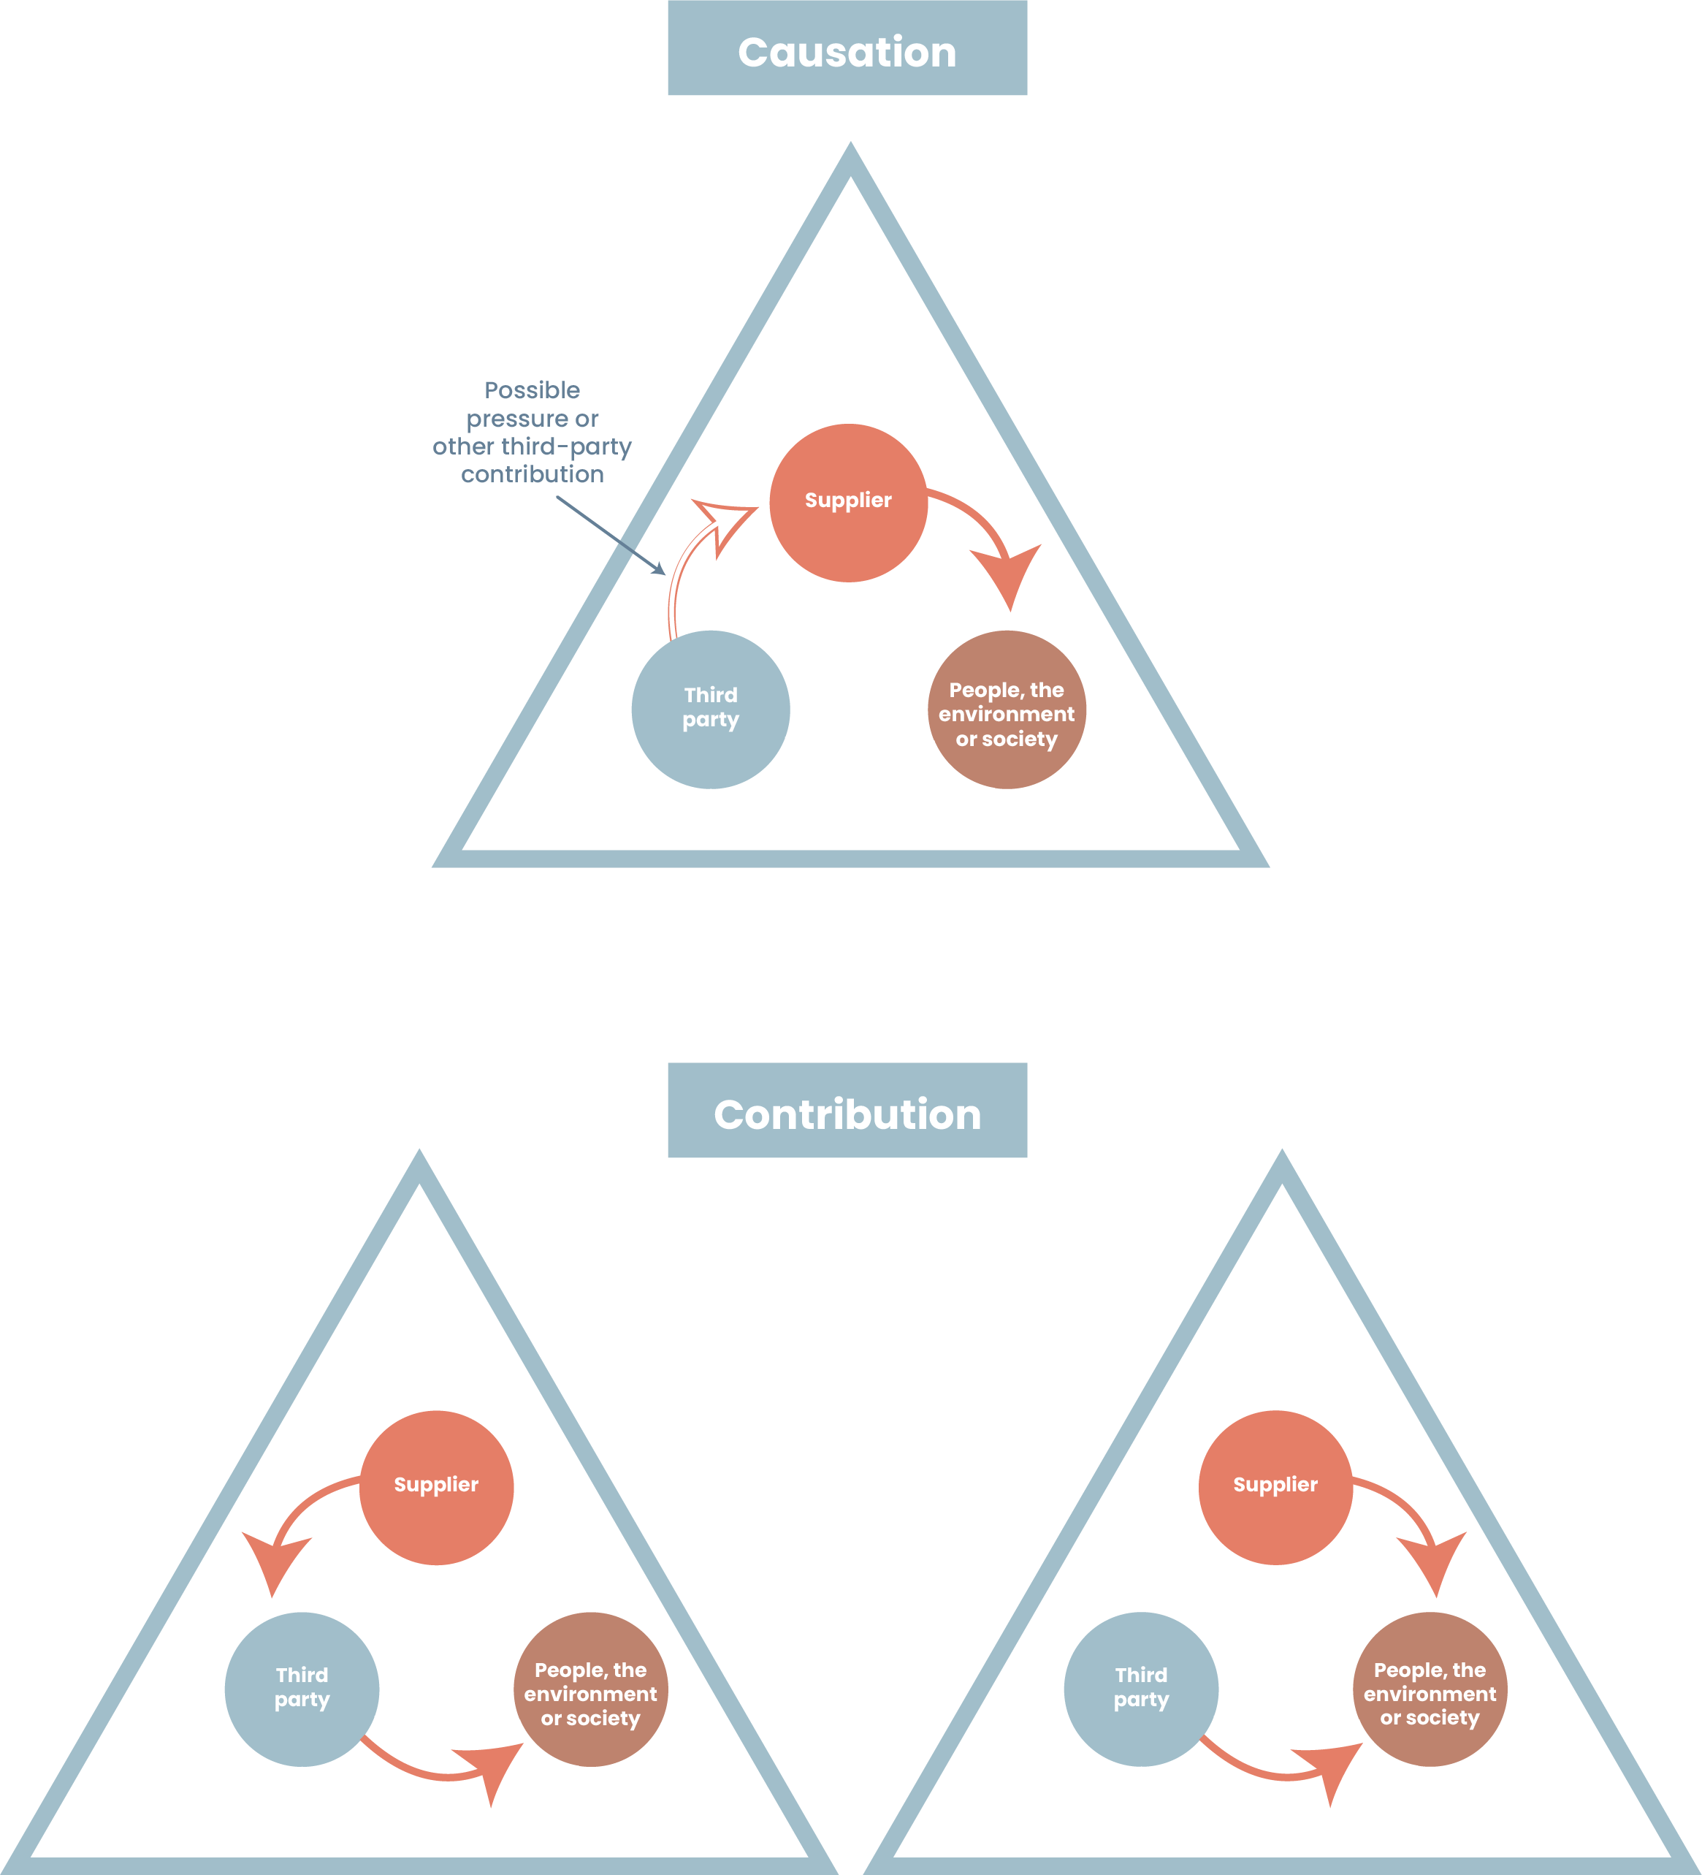

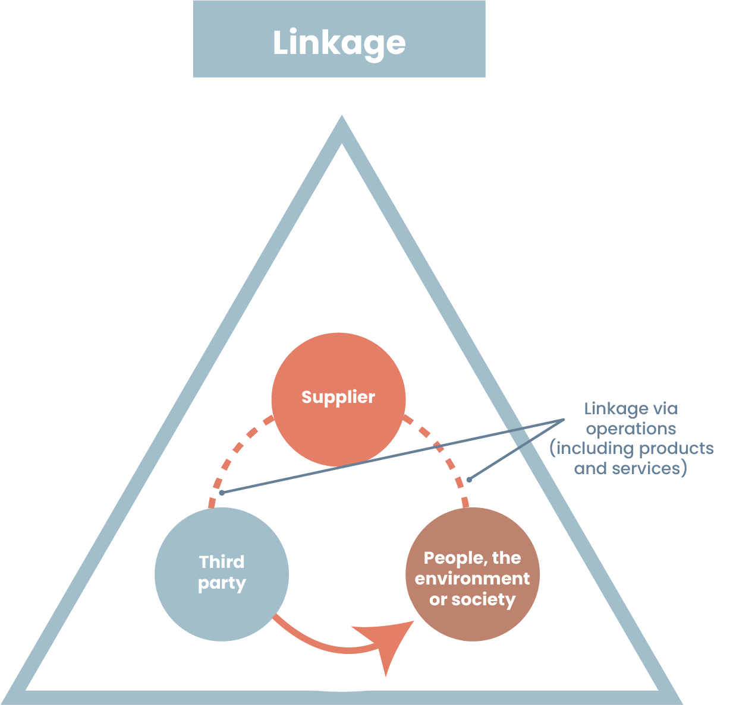

2.3.5 Monitoring of adverse impacts and updates of risk assessments
[Sustainability Managers] shall monitor adverse impacts in the supply chains of prioritised purchasing categories, through media, civil society, trade unions, academia etc., and update risk assessments without delay after significant changes occur or when new risks are identified.
3. Prevent, mitigate and bring adverse impacts to an end
[Procurement Managers/Contract Managers] shall, in consultation with [Sustainability Managers], bring to an end actual adverse impacts or minimise their extent, in proportion to their severity and [Company]’s involvement in the impact (causation, contribution or linkage).
3.1 Internal responses
3.1.1 Action plans
[Category Managers] shall, in consultation with [Procurement Managers, Contract Managers and Sustainability Managers], develop and implement (preventive/corrective) action plans for prioritised purchasing categories, with:
- Appropriate measures (see section 3.2) to address the prioritised adverse impacts in the specific case, depending on [Company]’s involvement (causation, contribution or linkage), in what tier the prioritised adverse impacts (may) occur(s), and [Company]’s leverage.
- Clearly defined responsibilities and reasonable timelines.
- Qualitative and quantitative indicators to track progress and improvement.
[Sustainability Managers] shall engage in meaningful consultations with affected stakeholders or their representatives as part of the development of action plans—ideally at the same time as the consultations on risks are conducted. Where direct engagement is not feasible, [Sustainability Managers] shall consult with experts who can provide credible insights into adverse impacts and otherwise use credible and independent sources.
[Category Managers] shall, in consultation with [Procurement Managers, Contract Managers and Sustainability Managers], follow up the implementation of the action plans—regularly and at least every 12 months, or without delay after significant changes occur or when new risks are identified. The follow-up shall focus on progress against the measures, timelines and indicators, and ensure that any deviations are addressed. It shall also, to the extent possible, be informed by meaningful consultations with affected stakeholders or their representatives.
3.1.2 Enhanced action plans
If a severe adverse impact cannot, or could not, be sufficiently addressed through (preventive/corrective) action plans, [Procurement Managers/Contract Managers] shall not enter new or extend existing contracts, unless they develop and implement an enhanced (preventive/ corrective) action plan for the specific adverse impact, in consultation with [Category Managers and Sustainability Managers]. This enhanced action plan may include a temporary suspension—provided there is reasonable expectations it will succeed—and shall include specific and appropriate timelines and responsibilities.
[Sustainability Managers] shall engage in meaningful consultations with affected stakeholders or their representatives as part of the development of the enhanced action plans. Where direct engagement is not feasible, [Sustainability Managers] shall consult with experts who can provide credible insights into adverse impacts and otherwise use credible and independent sources.
Where there is a need to balance the sourcing strategy with human rights, environmental, business ethics or [Company] reputational risks, the enhanced action plan shall be decided in [cross-functional decision forum].
[Procurement Managers/Contract Managers] shall, in consultation with [Category Managers and Sustainability Managers], follow up the implementation of the enhanced action plans—regularly and at least every 12 months, or without delay after significant changes occur or when new risks are identified. The follow-up shall focus on progress against the measures, timelines and responsibilities, and ensure that any deviations are addressed. It shall also, to the extent possible, be informed by meaningful consultations with affected stakeholders or their representatives.
3.1.3 Termination
If there is no reasonable expectation that an enhanced action plan will succeed, or if it has failed/fails to prevent, mitigate or bring to an end the specific adverse impact, [Contract Manager] shall terminate the contract as a last resort.
[Sustainability Managers] shall engage in meaningful consultations with affected stakeholders or their representatives, ahead of termination of the contract. Where direct engagement is not feasible, [Sustainability Managers] shall consult with experts who can provide credible insights into adverse impacts and otherwise use credible and independent sources.
3.1.4 Adverse impacts of suspension/termination
Before suspending or terminating the contract, [Sustainability Manager] shall assess whether doing so could lead to adverse impacts that are clearly more severe than the original impact. If so, the relationship may continue. [Sustainability Manager] shall document the assessment and the reasons for not suspending or terminating the business relationship [and make the document and reasons available to [supervisory authority] upon request].
If [Company] decides to suspend or terminate the business relationship, [Contract Manager] shall, in consultation with [Sustainability Manager], take steps to prevent, mitigate or bring to an end any adverse impacts caused by the suspension or termination, provide reasonable notice to the supplier, and continuously review the decision.
3.1.5 If no suspension/termination
If [Company] decides not to suspend or terminate the business relationship, [Sustainability Manager] shall monitor the adverse impact, and periodically reassess whether new or more effective measures are available.
3.2 Appropriate measures
3.2.1 Responsible purchasing practices
[Category Managers] shall, in consultation with [Procurement Managers, Contract Managers and Sustainability Managers] identify and address barriers in [Company]’s own purchasing practices and commercial terms that may hinder suppliers’ ability to comply with [Company]’s Supplier Code of Conduct or implement due diligence. Particular attention shall be paid to how [Company]’s purchasing practices may contribute to adverse impacts, see examples below:
Time pressure | Excessive overtime
Price pressure | Unfair wages
Last-minute order changes (e.g. increases in quantity or design changes) | Excessive overtime, insecure employment
Changes to payment terms during the contract period | Unfair wages
Take-it-or-leave-it contracts that hinder supplier compliance | Deficiencies in health and safety, unfair wages, excessive overtime, insecure employment
Insufficient weighting of sustainability in evaluation criteria | All commitments
Lack of remedy for contributions to adverse impacts | All commitments
Termination of contracts without responsible exits | All commitments

3.2.2 Leverage pre-contract
[Sustainability Managers] shall screen all suppliers against sanctions, politically exposed persons (PEPs), and adverse media, before entering contracts.
[Procurement Managers] shall, in consultation with [Sustainability Managers], commission or request independent third-party verifications (audits) of suppliers in prioritised purchasing categories before entering contracts. These audits may be commissioned directly from [consultancy]—or requested from suppliers if already commissioned by other parties—and may be conducted by industry or multi-stakeholder initiatives. Regardless of commissioning, audits shall have a particular focus on the prioritised adverse impacts in the specific case and be informed by meaningful consultations with affected stakeholders or their representatives. If an audit identifies severe adverse impacts, [Procurement Managers] shall require the supplier to correct and, where needed, remediate the severe adverse impacts before entering contracts.
[Procurement Managers] shall, in consultation with [Sustainability Managers], pre-qualify suppliers in prioritised purchasing categories based on due diligence and the prioritised adverse impacts in the specific case, and use award criteria for due diligence and prioritised adverse impacts where appropriate.
[Procurement Managers] shall require all suppliers to provide contractual assurances of compliance with [Company]’s Supplier Code of Conduct and to cascade these assurances to sub-suppliers. [Procurement Managers] may also seek contractual assurances directly from a sub-supplier in a prioritised purchasing category, with a view to achieving compliance with [Company]’s Supplier Code of Conduct.
[Procurement Managers] shall require suppliers in prioritised purchasing categories to conduct due diligence in line with the UN Guiding Principles on Business and Human Rights and the OECD Due Diligence Guidance for Responsible Business Conduct, to cascade this requirement to sub-suppliers and to disclose the suppliers and locations of final manufacturing and high-risk components and raw materials in the specific case.
When entering contracts or obtaining assurances from an SME, the terms shall be fair, reasonable, and non-discriminatory.
3.2.3 Leverage during contract
[Contract Managers] shall, in consultation with [Sustainability Managers], verify supplier compliance with [Company]’s Supplier Code of Conduct—focusing on the prioritised adverse impacts in the specific case—the due diligence requirements and requirements to disclose suppliers and locations, where applicable.
[Sustainability Managers] shall at least annually screen all suppliers against sanctions, politically exposed persons (PEPs), and adverse media.
[Contract Managers] shall, in consultation with [Sustainability Managers], request self-assessments from suppliers in prioritised purchasing categories [annually/every 3 years] and without undue delay after significant changes occur or when new risks are identified. The self-assessments shall have a particular focus on the prioritised adverse impacts and include questions designed to assess the supplier’s due diligence capacity. [Contract and Sustainability Managers] shall not request self-assessments from micro enterprises and shall ensure that requests to SMEs are targeted and proportionate.
Where the self-assessments indicate risks or a lack of sufficient due diligence, [Contract Managers] shall, in consultation with [Sustainability Managers], follow-up with independent third-party verifications (audits). These audits may be commissioned directly from [consultancy] or requested from suppliers if already commissioned by other parties, and may be conducted by industry or multi-stakeholder initiatives. Regardless of commissioning, audits shall have a particular focus on the prioritised adverse impacts in the specific case and be informed by meaningful consultations with affected stakeholders or their representatives. If an audit identifies adverse impacts, [Contract Managers] shall monitor that the supplier corrects and, where needed, remediates the adverse impacts.
[Contract Managers] may, in consultation with [Sustainability Managers], bypass self-assessments and proceed directly to audits, where appropriate. This may, for example, be the case if the supplier has already provided satisfactory answers during pre-qualification.
Where measures to verify compliance are carried out in relation to SMEs, [Procurement Department] shall bear the cost of independent third-party verifications (audits). Where the SME requests to pay at least a part of this cost, or if agreed with [Company], the SME may share the results of verifications (audits) with other companies.
[Contract Managers] shall, in consultation with [Sustainability Managers], provide targeted and proportionate support to SMEs in prioritised purchasing categories, including access to capacity-building, training, or upgrades of management systems. If Supplier is a micro enterprise, [Contract Managers] shall, in consultation with [Sustainability Managers] treat it as a rightsholder, uphold its rights as set out in the [Code of Conduct], and refrain from imposing measures that could jeopardize its viability or living income.
Where compliance with the requirements could jeopardise the SME’s viability, [Procurement Department] shall offer tailored financial support, such as direct financing, low-interest loans, sourcing guarantees (framework agreements), or assistance in securing financing.
[Contract Managers] shall, in consultation with [Sustainability Managers], engage quarterly with suppliers in prioritised purchasing categories about [Company’s] expectations—particularly regarding the management of prioritised adverse impacts and the disclosure of suppliers and locations. The engagements shall include [Company]'s provision of, or facilitation of access to, capacity-building, guidance, and administrative or financial support—such as loans or other forms of financing—depending on supplier's resources, knowledge, and constraints.
[Sustainability Managers] shall, in consultation with [Category Managers, Procurement Managers and Contract Managers], collaborate with other buyers of the same goods/services or with industry initiatives, where relevant, to increase [Company’s] leverage and the effectiveness of preventive and mitigating measures.
3.2.4 Severe adverse impact
If there is reasonable ground to believe that a severe adverse impact is occurring or has occurred somewhere in the supply chain, [Contract Managers]s, in consultation with [Sustainability Managers], without delay report this to the [incident/ deviation management system].
The severe adverse impact shall be addressed in accordance with sections 3.1.1–3.1.5.
4. Complaints and remediation
[Procurement Managers] shall enable complaints in the supply chain by making [Company]’s notification mechanism available through contract clauses on [Human Rights and Environmental Due Diligence Monitoring Committees].
[Contract Managers] shall, in consultation with [Sustainability Managers], address submitted complaints and provide for or cooperate in remediation in accordance with [instruction on Complaints Procedure].
5. Monitoring
[Chief Procurement Officer] shall, in consultation with [Category Managers, Procurement Managers, Contract Managers and Sustainability Managers] regularly assess and monitor the adequacy and effectiveness of the due diligence measures.
These assessments shall:
- Be carried out at least [annually/every three years], and without undue delay after significant changes occur or when new risks are identified.
- Be based on qualitative and quantitative indicators, where appropriate.
- Result in updates to policies, this instruction, risk assessments, and action plans, where needed.
- Consider relevant input from affected stakeholders, including on indicators, or, if direct consultation is not feasible, experts who can provide credible insights.
Specifically:
- [Chief Procurement Officer] shall own the overall monitoring framework — setting expectations, ensuring resources, and reporting to senior management.
- [Sustainability Managers] shall lead the design and execution of the assessments, including stakeholder engagements, development of indicators, coordination of data collection, and analysis. [Sustainability Managers] shall also collect and validate the data they are responsible for (supply chain mappings, risk assessments, screenings, multi-stakeholder initiatives).
- [Category Managers] shall review the implementation of category action plans, collect and validate the data on due diligence training, including responsible purchasing practices, and integrate findings into sourcing strategies and contract management strategies.
- [Procurement Managers] shall review the implementation of enhanced action plans, collect and validate the data they are responsible for (pre-contract audits, pre-qualifications, award criteria, contractual assurances) and integrate findings into sourcing strategies.
- [Contract Managers] shall review the implementation of enhanced action plans, collect and validate the data they are responsible for (audits during contract, supplier support, supplier engagements, complaints) and integrate findings into contract management strategies.

No frequency is set in the CSDDD. We recommend every 3 years. We also provide a template at www.hållbarupphandling.se/en/processkrav-2
We provide an e-learning and template at www.hållbarupphandling.se/en/processkrav-2.
No requirement, but frontrunner best practice.
We provide an e-learning and template at www.hållbarupphandling.se/en/processkrav-2.
www.hållbarupphandling.se/en/kallor [keep footnote]
“Shall requirement” in the Swedish Regions’ contract clause on due diligence for sustainable supply chains and covered by the risk assessment template; “should requirement” in the CSDDD.
Covered by the risk assessment template.
All three are CSDDD requirements (the first one is also a requirement in the Swedish Regions’ contract clause) and covered by the risk assessment template.
All companies should subscribe to the newsletter from the Business & Human Rights Resource Centre, at a minimum. There are many others.
Action plans are included in the risk assessment template.
www.hållbarupphandling.se/en/kallor [keep footnote]
Requirement in the Swedish Regions’ contract clause.
CSDDD requirements
www.hållbarupphandling.se/en/kallor [keep footnote]
Add the name of your company’s cross-functional decision forum. It usually includes functions such as Procurement, Sustainability, Risk Management, Communications and the executive team.
CSDDD requirement and requirement in the Swedish Regions’ contract clause.
www.hållbarupphandling.se/en/kallor [keep footnote]
CSDDD requirement and requirement in the Swedish Regions’ contract clause.
CSDDD requirement in [brackets]. Supervisory authority is not in place in Sweden yet.
We recommend the Toolkit (Buyer Code and European Model Clauses) collaboratively developed and hosted by the Responsible Contracting Project.
We provide a pre-qualification questionnaire (the questions can also be used as award criteria) at www.hållbarupphandling.se/en/processkrav-4.
We recommend the Toolkit (Buyer Code and model contract clauses) collaboratively developed and hosted by the Responsible Contracting Project.
CSDDD requirement.
In the current CSDDD version, it says every 12 months. In the Omnibus proposal, it says every 5 years. We recommend every 3 years.
CSDDD requirements.
CSDDD requirement.
CSDDD requirement.
”May” in CSDDD.
See the European Model Clauses at Responsible Contracting Project. We provide further guidance at www.hållbarupphandling.se/en/processkrav-6.
Add the name and reference to your company’s complaints procedure instruction.
CSDDD requirements. The frequency is annually in the current CSDDD version but every 5 years in the Omnibus proposal. For the purpose of CSRD reporting, we recommend every year.

