Due diligence instruction template

This template has been developed to help you meet the requirements of Article 7.2(**c**) of the Corporate Sustainability Due Diligence Directive, which calls for a description of the processes put in place to integrate and implement due diligence. It is also aligned with the UN Guiding Principles on Business and Human Rights and the OECD Due Diligence Guidance for Responsible Business Conduct, including its six steps. It means that if your company is not in scope of the Directive, this template can still support your efforts to strengthen internal coherence and meet stakeholder expectations.

*To ensure that you align with best practices, the instruction takes a value chain approach (own operations, upstream and downstream), not the limited “chain of activities” approach in the Corporate Sustainability Due Diligence Directive.*

The instruction is meant to complement other governance structures such as your environmental management system, compliance management system, responsible sourcing instruction, complaints procedure and/or whistleblowing procedure. See the Due diligence policy template—developed to help you meet the requirements of Article 7.2(**a**) of the Corporate Sustainability Due Diligence Directive—for more information.

The instruction should be tailored to reflect your company’s practices—for instance, you may not have different business areas/units or operational sites. Before tailoring it, ensure that the “Annex: Responsibilities” at the end of the document is finalised.

Footnotes provide guidance for your understanding—**delete them**.

Note that according to the Corporate Sustainability Due Diligence Directive, you shall develop this instruction in consultation with your employees and their representatives.

**Due Diligence**

**Purpose**

This instruction sets rules for [company]’s human rights due diligence across the value chain, as well as for environmental and societal due diligence upstream and downstream.

Environmental and societal impacts in [company’s] own operations are managed under the [environmental management system] and the [compliance system].

This instruction is furthermore complemented by the [responsible sourcing instruction], [complaints procedure], and [whistleblowing procedure].[1]

For illustrative purposes, the instruction follows the OECD Due Diligence process:

**Target Groups**

**Basic knowledge**

The following groups shall have basic knowledge of this instruction (know it exists, the main purpose of it, and where to find it):

* All employees
* Contractors and agency workers
* Works councils and employee representatives

**Thorough knowledge**

The following groups shall have thorough knowledge of this instruction (know the details, roles, and responsibilities) and comply with the roles and responsibilities described herein:

* Board of Directors (oversight role)
* CEO [and Executive Management Team]
* Heads of Staff Functions
* [Heads of Business Areas / Business Units]
* Compliance and Internal Audit functions
* Employees whose actions and decisions are most likely to increase or decrease risks

**Terms**

| Term | Meaning in this instruction |
| --- | --- |
| Due diligence | Ongoing process through which [company] identifies, prevents, mitigates, tracks, and communicates on actual and potential adverse impacts in its operations and value chain. |
| Accountability | Ultimate answerability for impacts. Cannot be delegated, only exercised. |
| Responsibility | Day-to-day role in implementing due diligence policies and procedures. |
| Value chain | Own operations and upstream and downstream activities, entities, and countries, including subsidiaries, suppliers, contractors, distributors, and end-users. |
| Upstream | Activities, entities, and countries involved in supplying goods, services, and raw materials to [company]. |
| Downstream | Activities, entities, and countries involved in distributing, using, and disposing of [company]’s products or services. |
| Adverse impacts | Negative impacts on human rights across the value chain, including own operations, and negative impacts on the environment and society in the upstream and downstream value chain. |
| Salient issues | Those adverse impacts that stand out as being most at risk. |
| Affected stakeholder | Individual, group, or community that is or may be adversely affected by [company]’s operations or value chain. |
| Meaningful stakeholder engagement | Engagement with affected stakeholders that is based on two-way communication, conducted in good faith, and responsive and ongoing. |
| Scale, scope, and irremediability | Framework to determine the severity of an adverse impact. |
| Causation, contribution, linkage | Framework to determine company’s involvement in an adverse impact. |
| Action plan | Internal plan that sets out measures to stop, minimise, prevent, or mitigate adverse impacts. In this instruction, action plan covers both preventive and corrective action plans under the Corporate Sustainability Due Diligence Directive (Articles 10 and 11). |
| Shared responsibility | Principle that buyers and suppliers jointly contribute to managing risks, rather than shifting responsibility upstream. |
| Responsible purchasing practices | Purchasing practices that support positive human rights and environmental outcomes, e.g., fair prices, reasonable deadlines, and adequate assistance. |
| Due diligence action plan | Internal plan that sets targets and actions to strengthen [company]’s/Staff Functions’ [and Business Areas] policies and procedures. |
| Complaints procedure | Process allowing external stakeholders to raise human rights or environmental concerns. |
| Whistleblowing procedure | Confidential procedure for reporting breaches of law or business ethics. |
| Remediation | Process and measures to restore or compensate affected stakeholders when harm has occurred. |

**1. Embed responsible business conduct**

**1.1 Responsibilities**

The Board of Directors has ultimate oversight of actual and potential adverse impacts across [company’s] operations and value chains, while the CEO is accountable for managing these impacts.

The Heads of Staff Functions [and Business Areas] are accountable to the CEO for actual and potential adverse impacts in their Staff Functions [and Business Areas].

[The Heads of Business Units are accountable to the Heads of Business Areas for actual and potential adverse impacts in their Business Units.]

The Heads of [Staff Functions Sustainability and Procurement / Supply Chain] are accountable to the CEO for actual and potential adverse impacts in [company’s] upstream and downstream value chains.

[Staff Function Sustainability] is responsible for [company’s] Due Diligence Policy, Human Rights Policy, [Responsible Minerals Policy,] Supplier [& Partner] Code of Conduct, and this Due Diligence Instruction, as integrated parts of [company’s] management system.[2]

All managers are responsible for ensuring that roles and responsibilities are clearly communicated, understood by all parties, and integrated into job descriptions, performance targets, and incentives.

**1.2 Compliance**

The Heads of Staff Functions [and Business Areas] are responsible for compliance with legal requirements across the value chain, while [Legal Entity] is legally accountable. All legal requirements must be complied with, and internal and external commitments must be fulfilled.

[Business Areas are responsible for permit applications, for identifying legal requirements, for assessing these legal requirements with respect to consequences on their respective activities, and for implementing compliance measures.][3]

[Staff Function Legal] shall maintain and update a register of applicable laws and voluntary commitments, including industry and multi-stakeholder initiatives.

Compliance establishes the minimum standard. Due diligence ensures that [company] addresses impacts not yet covered by legal requirements.

**1.3 Monitoring of legal and policy developments**

[Staff Function Public and Regulatory Affairs],[4] in consultation with [Staff Functions Legal and Sustainability] [and Business Areas], shall monitor legal and policy developments across the value chain and assess their possible impact on [company’s] operations.

[Staff Function Public and Regulatory Affairs] shall ensure that [company’s] position on new legislation is aligned with the policies set under 1.4 and is agreed internally before being communicated externally.

[Staff Function Public and Regulatory Affairs] shall ensure that all advocacy adheres to this agreed position and shall be responsible for lobbying in consultation with [Staff Functions Sustainability and Legal].

**1.4 Policies and procedures**

Staff Functions, in consultation with other Staff Functions [and Business Areas], shall set the strategic direction of [company] and shall develop, review, and update policies and procedures in their areas of responsibility (see Annex: Responsibilities). Policies and procedures shall be reviewed and, where needed, updated at least every 24 months and without undue delay when major changes occur or new risks arise[, in accordance with [section X.X] in the Management System]. Policies and procedures shall be informed by external expertise, such as credible resources and recognized experts.

The CEO or the Board of Directors shall approve all policies [in accordance with section X.X of the Management System].

Staff Functions shall translate the policies into local languages, English, and, where relevant, the main languages of the primary countries in the upstream and downstream value chain,[5] [in accordance with [section X.X] in the Management System].

Staff Functions shall communicate the policies to employees and other workers through [intranet], during staff onboarding and training, and periodically as needed to maintain awareness, and shall make them available at premises where relevant.[6]

[Staff Function Communications] shall make the policies publicly available on [company’s] external website.

**1.5 Information management and cross-functional alignment**

Staff Functions [and Business Areas] shall adapt existing information and record-keeping systems, or develop new ones where needed, to integrate due diligence, related decision-making, and responses.

Staff Functions [and Business Areas] shall use existing communication channels between senior management and implementing departments, or establish new ones where needed, for sharing and documenting impacts and decisions.

Staff Functions shall ensure alignment across Staff Functions [and Business Areas] through cross-functional groups, including:

* [high-risk sourcing decisions]
* [critical incidents/complaints]
* [reporting and disclosures]
* [xxx]

**1.6 Training**

Staff Functions shall provide training to employees and other workers to ensure understanding and implementation of [company’s] policies and procedures. Such training shall be delivered at staff onboarding, refreshed periodically, and updated as new risks or requirements emerge.

[Business Areas shall, where needed, provide targeted training tailored to their activities and responsibilities, including information on risks and liabilities.]

**1.7 Complaints and whistleblowing procedures[7]**

Staff Functions [and Business Areas] shall comply with the [Complaints Procedure],[8] which governs how complaints regarding actual or potential adverse impacts across [company’s] value chains are addressed.

Staff Functions [and Business Areas] shall comply with the [Whistleblowing Procedure],[9] which provides a confidential channel for reporting breaches of law or other concerns, including business ethics.

**1.8 Supplier [and partner] relationships**

[Staff Functions Sustainability and Procurement / Supply Chain] shall comply with the [Responsible Sourcing Instruction][10] when engaging suppliers [and partners]. The [Responsible Sourcing Instruction] sets out the due diligence steps specifically for sourcing.

[Staff Function Legal], in consultation with [Staff Functions Sustainability and Procurement / Supply Chain], shall ensure that due diligence contract clauses are based on the principles of shared responsibility, responsible purchasing practices and remediation first, adaptable depending on supplier [or partner] size, capacity and risk,[11] and accompanied by appropriate methods to verify compliance.

**2. Identify and Assess Adverse Impacts**

**2.1 Mapping and scoping**

[Staff Function Sustainability] shall, at least every [36] months, or whenever [company] makes a significant change to the business, carry out a mapping and scoping exercise of [company’s] operations and value chains to identify areas where actual and potential adverse impacts are most likely to occur and be most severe, and determine salient issues.[12]

[Staff Function Sustainability] shall meaningfully engage with affected stakeholders or their representatives (see 2.3), and consider information raised through complaints procedures. Where direct engagement is not feasible (upstream or downstream), the scoping and mapping exercise shall be informed by credible resources and recognized experts.

[Staff Function Sustainability] shall pay special attention to vulnerable groups, including at a minimum women, children, migrant workers, minorities, persons with disabilities, and indigenous peoples.[13]

**2.2 In-depth assessments**

Staff Functions [and Business Areas] shall identify and assess actual and potential adverse impacts in their areas of responsibility (see Annex: Responsibilities) at least every 12 months and without undue delay when major changes occur or when new risks arise. Such assessments shall include both areas with the most likely and most severe adverse impacts identified through 2.1 and assessments required under specific legal requirements.[14]

[Business Areas shall identify and assess actual and potential adverse impacts in the development (permitting) phase of projects, as well as during project delivery, operations and maintenance, and decommissioning.][15]

Staff Functions [and Business Areas] shall meaningfully engage with affected stakeholders or their representatives (see 2.3), and consider information raised through complaints procedures. Where direct engagement is not feasible (upstream or downstream), the in-depth assessments shall be informed by credible resources and recognized experts.

Staff Functions [and Business Areas] shall pay special attention to vulnerable groups, including at a minimum women, children, migrant workers, minorities, persons with disabilities, and indigenous peoples.[16]

Staff Functions [and Business Areas] shall prioritise the identified actual and potential adverse impacts based on likelihood and severity. Severity shall be judged by the adverse impacts’:

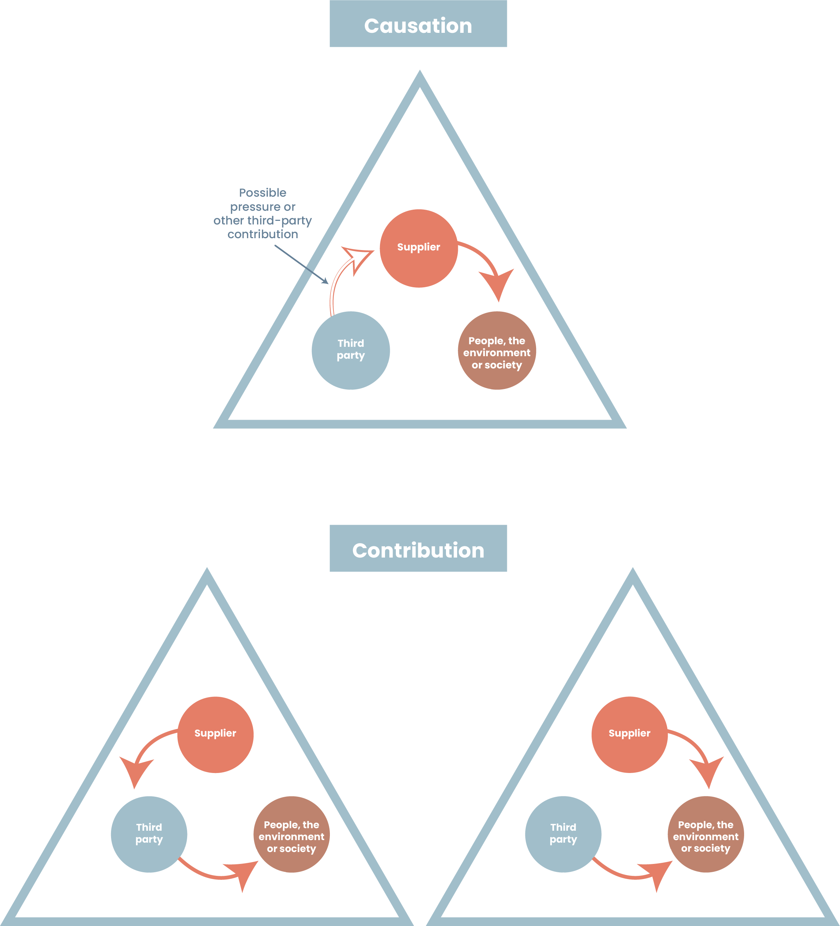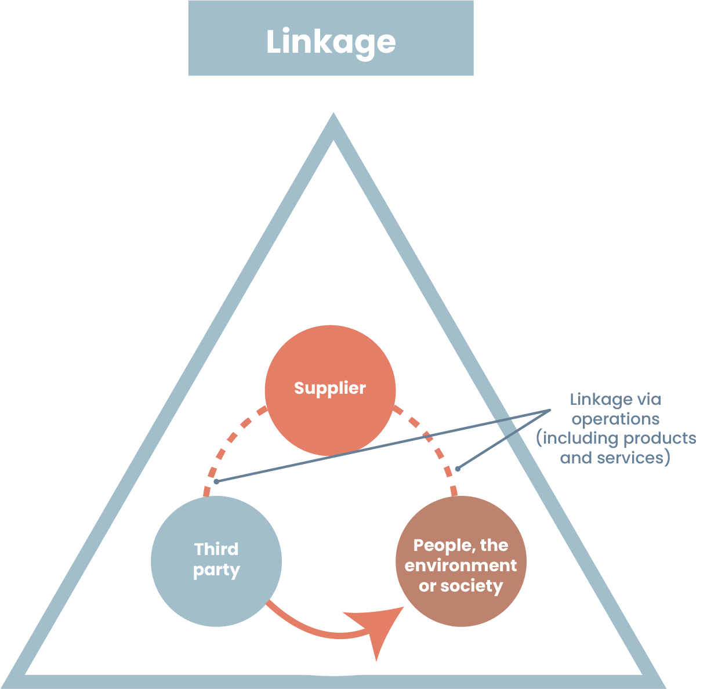

|  |  |
| --- | --- |
| **Scale** | The gravity of the adverse impact. |
| **Scope** | The reach of the adverse impact, for example the number of individuals that are or will be affected or the extent of environmental damage. |
| **Irremediable character** | Any limits on the ability to restore the individuals or environment affected to a situation equivalent to their situation before the adverse impact. |

Staff Functions [and Business Areas] shall determine [company’s] involvement in actual and potential adverse impacts (causation, contribution, linkage[17]).

**2.3 Meaningful stakeholder engagements**

Staff Functions [and Business Areas] shall ensure that stakeholder engagement is based on two-way communication, conducted in good faith, and carried out in a responsive and ongoing manner.[18]

Staff Functions [and Business Areas] shall provide stakeholders with relevant and comprehensive information to enable effective and transparent consultations. Where stakeholders make a reasoned request for additional information, this shall be provided within a reasonable time and in an appropriate and comprehensible format. Where the request cannot be met, Staff Functions [and Business Areas] shall provide a written justification.[19]

Staff Functions [and Business Areas] shall identify and address barriers to engagement and ensure that participants are not the subject of retaliation or retribution, including through confidentiality or anonymity.[20]

**2.4 External monitoring**

[Staff Function Risk & Resilience] shall monitor actual and potential adverse impacts in international, national and local media, and provide updates in [briefing].[21]

**3. Cease, Prevent and Mitigate**

**3.1 Due diligence action plans[22]**

[Staff Function Sustainability] shall develop and implement a due diligence action plan to address gaps in [company’s] due diligence policies and procedures.

Staff Functions [and Business Areas] shall develop and implement due diligence action plans to address gaps in the Staff Function’s [or Business Area’s] due diligence policies and procedures.

[Staff Function Sustainability] shall assist other Staff Functions [and Business Areas] in developing due diligence action plans.

**3.2 Action plans to address actual and potential adverse impacts**

Staff Functions [and Business Areas] shall immediately stop activities[23] that are causing or contributing to *actual* adverse impacts. Where stopping an activity is complex, difficult, or if the activity is essential for the business, Staff Functions [and Business Areas] shall, without undue delay, develop and implement action plans, with reasonable and clearly defined timelines, to stop or minimise the adverse impacts. Staff Functions [and Business Areas] shall furthermore develop and implement measures to prevent and mitigate *potential* adverse impacts.[24]

Action plans shall include, where necessary, investments and adjustments to facilities, production or operational processes, and infrastructures, as well as modifications of business plans, strategies, and operations, including purchasing practices, design, and distribution.[25]

Where [company] is one of several entities contributing to an adverse impact, the relevant Staff Function [or Business Area] shall engage with other involved entities to cease, prevent or mitigate the impacts.

Where [company] is contributing to an adverse impact caused by another entity, the relevant Staff Function [or Business Area] shall take steps to cease, prevent, or mitigate its contribution, and use leverage to mitigate any remaining impact.

Staff Functions [and Business Areas] shall meaningfully engage with affected stakeholders or their representatives (see 2.3) on the action plans to address actual and potential adverse impacts. Where direct engagement is not feasible (upstream or downstream), the action plans shall be informed by credible resources and recognized experts.

**4. Track**

**4.1 Indicators**

Staff Functions [and Business Areas] shall develop qualitative and quantitative indicators to be integrated in business planning and action plans.

Staff Functions [and Business Areas] shall meaningfully engage with affected stakeholders or their representatives (see 2.3) in the development of indicators.[26] Where direct engagement is not feasible (upstream or downstream), the indicators shall be informed by credible resources and recognized experts.

**4.2 Monitoring of action plans to address adverse impacts**

Staff Functions [and Business Areas] shall monitor the action plans to address actual and potential adverse impact.

Staff Functions [and Business Areas] shall meaningfully engage with affected stakeholders or their representatives (see 2.3) in the monitoring of action plans.[27] Where direct engagement is not feasible (upstream or downstream), the monitoring of action plans shall be informed by credible resources and recognized experts.

**4.3 Due diligence reviews**

Staff Functions [and Business Areas] shall conduct due diligence reviews (DDR) at least every 12 months and without undue delay after significant changes occur or whenever there are reasonable grounds to believe new adverse impacts may arise. The reviews shall monitor the implementation of due diligence action plans and assess the adequacy and effectiveness of due diligence. The management team, including the Head of Staff Function [or Business Area], shall be present at the DDR. A representative from [Staff Function Sustainability] shall be invited.

[Staff Function Sustainability] shall conduct a corporate due diligence review (CDDR) at least every 12 months and without undue delay after significant changes occur or whenever there are reasonable grounds to believe new adverse impacts may arise. The reviews shall monitor the implementation of the corporate due diligence action plan and assess the adequacy and effectiveness of due diligence. The management team, including the CEO and the Head of [Staff Function Sustainability], shall be present.

As a minimum, the following topics shall be addressed during the DDR and CDDR:

* Severe actual and potential adverse impacts, complaints and remediation.
* Implementation and effectiveness of due diligence action plans.
* Changing circumstances, including new risks, significant organisational changes, and developments in legal and other requirements.
* Compliance with legal requirements, internal instructions and any other commitments.
* Extent to which decisions from the previous DDR/CDDR have been implemented.
* Adequacy of resources, competence, and cross-functional cooperation.
* Lessons learned and feedback from stakeholders to improve processes and outcomes.
* Recommendations and decisions for improvement, including future actions and resource needs.

The results of the DDR and CDDR shall be documented and feed into due diligence action plans.

To secure implementation, the DDR shall be executed in [Q1] and the CDDR in [Q2], prior to the annual business planning process. [Staff Functions [and Business Areas] shall summarise the DDR in the [CEO Talk on performance and objectives in [Q3].]

**4.4 Reviews of multi-stakeholder and industry initiatives[28]**

[Staff Function Sustainability] shall, every 24 months, review the multi-stakeholder initiatives to which [company] is a signatory, in consultation with other Staff Functions [and Business Areas]. Reviews shall assess whether the initiatives are appropriate to fulfil due diligence obligations, including:

* alignment with due diligence
* value in helping [company] identify, prevent or mitigate adverse impacts, and
* their independence.

[Staff Function Public and Regulatory Affairs] shall, every 24 months, review the industry initiatives to which [company] is a signatory, in consultation with Staff Function Sustainability [and Business Areas]. Reviews shall assess whether the initiatives are appropriate to fulfil due diligence obligations, including:

* alignment with due diligence
* value in helping [company] identify, prevent or mitigate adverse impacts, and
* their independence.

**5. Communicate**

**5.1 Progress report[29]**

[Staff Function Sustainability] shall, every 12 months, prepare a progress report in an accessible format. The report shall include:

* measures taken to embed responsible business conduct
* salient issues
* measures taken to cease, prevent, or mitigate adverse impacts
* measures used to track implementation and results
* provisions of, or cooperation in, remediation.

[Staff Function Communications] shall make the report publicly available on [company’s] external website.

**5.2 [Annual and] sustainability report**

[Staff Function CFO] shall annually report on [company’s] due diligence, in consultation with [Staff Function Sustainability and Staff Function Communications]. [The report shall be aligned with the Corporate Sustainability Reporting Directive and the European Sustainability Reporting Standards.]

[Staff Function Communications] shall make the report publicly available on [company’s] external website.

**5.3 Disclosures on external website**

[Staff Function Communications] shall disclose [company’s] salient issues and due diligence process on [company’s] external website, in consultation with [Staff Function Sustainability].[30]

**[5.4 Disclosures on project webpages[31]**

Business Areas shall disclose all relevant information to affected stakeholders or their representatives through the project webpages. This is particularly relevant when concerns are raised by them or on their behalf. The information shall include:

* links to relevant policies, [Complaints Procedure] and [Whistleblowing Procedure]
* identified stakeholders including particularly vulnerable groups,
* planned/conducted stakeholder engagements/consultations, and the results of impact assessments
* planned/conducted actions to cease, prevent or mitigate the impacts, including agreements
* actual impacts identified during monitoring of the plans to cease, prevent or mitigate impacts
* remediation plans and results
* contact information for meaningful stakeholder engagement (see 2.3).]

**5.5 Strategic communication**

[Staff Function Communications], in consultation with [Staff Function Sustainability] [and Business Areas], shall set messaging on potential and actual adverse impacts (website, social media, etc.).

**5.6 Benchmarks and investor/ customer requests**

[Staff Function Sustainability] shall respond to [group-wide] benchmarks and investor/customer requests, in consultation with other Staff Functions [and Business Areas] as needed[, and provide a registry of answers to Business Areas].

[Business Areas shall respond to Business Area benchmarks and investor/customer requests, based on the registry of answers.][32]

**6. Provide for or Cooperate in Remediation**

If [company] has caused or contributed to an actual adverse impact, the relevant Staff Function [or Business Area] shall provide for or cooperate in its remediation.

If [company] is linked to an actual adverse impact, the relevant Staff Function [or Business Area] shall use its leverage, to the extent practicable, to influence the entity causing the actual adverse impact to remedy it.

Staff Functions [and Business Area] shall, provide for or cooperate in remediation in accordance with [Complaints Procedure].[33]

**Revision history**

| Issue Number | Revisions | Approved by |
| --- | --- | --- |
| 1.0 valid from [YYMMDD) | New document | Head of Quality |

**Annex: Responsibilities**

*Fill out the “Responsible functions” column below based on your company’s impacts and functions. The table follows the European Sustainability Reporting Standards topics, sub-topics, and sub-sub-topics. Consider* ***all*** *your adverse impacts on people and the planet[34] — not only those you have identified as “material” in your double materiality assessment under the Corporate Sustainability Reporting Directive.*

*Remove any impacts that are not relevant to your business but ensure you have considered your full value chain. The impacts and responsible functions will differ depending on your operations — for example, whether you are an extractive, processing or manufacturing company, or a retailer or wholesaler with stores or office operations, and depending on the goods, works, or services you use or provide.*

*Refer to the responsible functions when completing the Due Diligence Instruction template above. Delete this instructional text (in italics) before finalising the annex.*

|  |  |  |  |
| --- | --- | --- | --- |
| **Topics** | **Sub-topics** | **Sub-sub-topics** | **Responsible functions** |
| **Climate change** | Climate change adaptation |  | [Sustainability / Environment; Operations / Facilities; R&D / Product Stewardship] |
| Climate change mitigation |  | [Sustainability / Environment; Operations / Facilities; R&D / Product Stewardship; Procurement / Supply Chain] |
| Energy |  | [Sustainability / Environment; Operations / Facilities; R&D / Product Stewardship; Information Security; Procurement / Supply Chain] |
| **Pollution** | Pollution of air |  | [Sustainability / Environment; Health & Safety; Operations / Facilities; Procurement / Supply Chain] |
| Pollution of water |  | [Sustainability / Environment; Health & Safety; Operations / Facilities; Procurement / Supply Chain] |
| Pollution of soil |  | [Sustainability / Environment; Health & Safety; Operations / Facilities; Procurement / Supply Chain] |
| Pollution of living organisms and food resources |  | [Sustainability / Environment; Health & Safety; Operations / Facilities; Procurement / Supply Chain] |
| Substances of concern |  | [Sustainability / Environment; Health & Safety; R&D / Product Stewardship; Procurement / Supply Chain] |
| Substances of very high concern |  | [Sustainability / Environment; Health & Safety; R&D / Product Stewardship; Procurement / Supply Chain] |
| Microplastics |  | [Sustainability / Environment; Health & Safety; R&D / Product Stewardship; Procurement / Supply Chain] |
| **Water and marine resources** | Water and Marine resources | Water consumption | [Sustainability / Environment; Community Relations; Operations / Facilities; Information Security; Procurement / Supply Chain] |
| Water withdrawals | [Sustainability / Environment; Community Relations; Operations / Facilities; Procurement / Supply Chain] |
| Water discharges | [Sustainability / Environment; Community Relations; Health & Safety; Operations / Facilities; Procurement / Supply Chain] |
| Water discharges in the oceans | [Sustainability / Environment; Community Relations; Health & Safety; Operations / Facilities; Procurement / Supply Chain] |
| Extraction and use of marine resources | [Sustainability / Environment; Community Relations; R&D / Product Stewardship; Procurement / Supply Chain] |
| **Biodiversity and ecosystems** | Direct impact drivers of biodiversity loss | Climate change | [Sustainability / Environment; R&D / Product Stewardship; Operations / Facilities; Procurement / Supply Chain] |
| Land-use change, fresh water-use change and sea-use change | [Sustainability / Environment; Community Relations; Operations / Facilities; Procurement / Supply Chain] |
| Direct exploitation | [Sustainability / Environment; Community Relations; Operations / Facilities; Procurement / Supply Chain] |
| Invasive alien species | [Sustainability / Environment; Community Relations; Operations / Facilities; Procurement / Supply Chain] |
| Pollution | [Sustainability / Environment; Community Relations; Operations / Facilities; Health & Safety; R&D / Product Stewardship; Procurement / Supply Chain] |
| Others | [Sustainability / Environment; Community Relations; Operations / Facilities; Procurement / Supply Chain] |
| Impacts on the state of species | Species population size | [Sustainability / Environment; Community Relations; Operations / Facilities; Procurement / Supply Chain] |
| Species global extinction risk | [Sustainability / Environment; Community Relations; Operations / Facilities; Procurement / Supply Chain] |
| Impacts on the extent and condition of ecosystems | Land degradation | [Sustainability / Environment; Community Relations; Operations / Facilities; Procurement / Supply Chain] |
| Desertification | [Sustainability / Environment; Community Relations; Operations / Facilities; Procurement / Supply Chain] |
| Soil sealing | [Sustainability / Environment; Community Relations; Operations / Facilities; Procurement / Supply Chain] |
| Impacts and dependencies on ecosystem services |  | [Sustainability / Environment; Community Relations; Operations / Facilities; R&D / Product Stewardship; Procurement / Supply Chain] |
| **Circular economy** | Resources inflows, including resource use |  | [Sustainability / Environment; R&D / Product Stewardship; Procurement / Supply Chain] |
| Resource outflows related to products and services |  | [Sustainability / Environment; R&D / Product Stewardship; Operations / Facilities; Procurement / Supply Chain] |
| Waste |  | [Sustainability / Environment; R&D / Product Stewardship; Health & Safety; Operations / Facilities; Information Security] |
| **Own workforce** | Working conditions | Secure employment | [Human Resources] |
| Working time | [Human Resources] |
| Adequate wages | [Human Resources] |
| Social dialogue | [Human Resources] |
| Freedom of association, works councils, participation rights | [Human Resources] |
| Collective bargaining | [Human Resources] |
| Work-life balance | [Human Resources] |
| Health and safety | [Human Resources including Health & Safety] |
| Equal treatment and opportunities for all | Gender equality and equal pay | [Human Resources] |
| Training and skills development | [Human Resources] |
| Employment and inclusion of persons with disabilities | [Human Resources] |
| Measures against violence and harassment in the workplace | [Human Resources] |
| Diversity | [Human Resources] |
| Other work-related rights | Child labour | [Human Resources] |
| Forced labour | [Human Resources] |
| Adequate housing | [Human Resources including Health & Safety] |
| Privacy | [Legal / Compliance; Information Security] |
| **Workers in the value chain** | Working conditions | Secure employment | [Sustainability; Procurement / Supply Chain] |
| Working time | [Sustainability; Procurement / Supply Chain] |
| Adequate wages | [Sustainability; Procurement / Supply Chain] |
| Social dialogue | [Sustainability; Procurement / Supply Chain] |
| Freedom of association, works councils | [Sustainability; Procurement / Supply Chain] |
| Collective bargaining | [Sustainability; Procurement / Supply Chain] |
| Work-life balance | [Sustainability; Procurement / Supply Chain] |
| Health and safety | [Sustainability; Procurement / Supply Chain] |
| Equal treatment and opportunities for all | Gender equality and equal pay | [Sustainability; Procurement / Supply Chain] |
| Training and skills development | [Sustainability; Procurement / Supply Chain] |
| Employment and inclusion of persons with disabilities | [Sustainability; Procurement / Supply Chain] |
| Measures against violence and harassment in the workplace | [Sustainability; Procurement / Supply Chain] |
| Diversity | [Sustainability; Procurement / Supply Chain] |
| Other work-related rights | Child labour | [Sustainability; Procurement / Supply Chain] |
| Forced labour | [Sustainability; Procurement / Supply Chain] |
| Adequate housing | [Sustainability; Procurement / Supply Chain] |
| Water and sanitation | [Sustainability; Procurement / Supply Chain] |
| Privacy | [Sustainability; Procurement / Supply Chain] |
| **Affected communities** | Communities’ economic, social and cultural rights | Adequate housing | [Sustainability; Community Relations; Procurement / Supply Chain] |
| Adequate food | [Sustainability; Community Relations; Procurement / Supply Chain] |
| Water and sanitation | [Sustainability; Community Relations; Procurement / Supply Chain] |
| Land-related impacts | [Sustainability; Community Relations; Legal; Real Estate / Land Management; Procurement / Supply Chain] |
| Security-related impacts | [Sustainability; Community Relations; Security; Information Security; Procurement / Supply Chain] |
| Communities’ civil and political rights | Freedom of expression | [Sustainability; Community Relations; Information Security; Legal; Procurement / Supply Chain] |
| Freedom of assembly | [Sustainability; Community Relations; Information Security; Legal; Procurement / Supply Chain] |
| Impacts on human rights defenders | [Sustainability; Community Relations; Information Security; Legal; Procurement / Supply Chain] |
| Rights of indigenous peoples | Free, prior and informed consent | [Sustainability; Community Relations; Legal; Procurement / Supply Chain] |
| Self-determination | [Sustainability; Community Relations; Legal; Procurement / Supply Chain] |
| Cultural rights | [Sustainability; Community Relations; Legal; Procurement / Supply Chain] |
| **Consumers and end-users** | Information-related impacts | Privacy | [Legal / Compliance; Information Security] |
| Freedom of expression | [Marketing / Communications; Information Security] |
| Access to (quality) information | [Marketing / Communications; Information Security] |
| Personal safety | Health and safety | [Product Safety / Quality; Information Security] |
| Security of a person | [Product Safety / Quality; Information Security] |
| Protection of children | [Product Safety / Quality; Information Security] |
| Social inclusion | Non-discrimination | [Marketing / Communications] |
| Access to products and services | [Marketing / Communications] |
| Responsible marketing practices | [Marketing / Communications] |
| **Business conduct** | Corporate culture |  | [Legal / Compliance; Human Resources] |
| Protection of whistle-blowers |  | [Legal / Compliance; Information Security] |
| Animal welfare |  | [Sustainability / Environment; R&D / Product Stewardship; Procurement / Supply Chain] |
| Political engagement and lobbying activities |  | [Legal / Compliance] |
| Management of relationships with suppliers including payment practices |  | [Procurement / Supply Chain] |
| Corruption and bribery | Prevention and detection including training | [Legal / Compliance] |
| Incidents | [Legal / Compliance] |

1. Adapt if only one procedure is used, but be aware that the Corporate Sustainability Due Diligence Directive and the Whistleblowing Directive have different requirements.
2. Add other relevant policies, such as Sustainability Policy and Battery Due Diligence Policy (if you have not merged it with the Due Diligence Policy).
3. Only relevant if you have business areas and activities/operational sites requiring permits.
4. For larger companies, spanning several markets, this may need to be divided into EU and national. In smaller companies, monitoring of legal/policy developments may be handled by Sustainability/Legal.
5. Primarily relevant for the Supplier [and Partner] Code of Conduct.
6. Mainly relevant for health & safety, anti-discrimination and harassment policies etc.
7. Merge the paragraphs if only one procedure is used, but be aware that the Corporate Sustainability Due Diligence Directive and the Whistleblowing Directive have different requirements.
8. To avoid duplication of processes, refer to the relevant governance document. See also the “Complaints procedure template”.
9. To avoid duplication of processes, refer to the relevant governance document.
10. To avoid duplication of processes, refer to the relevant governance document. See also the “Responsible Sourcing Instruction template”.
11. Avoid having due diligence requirements in the Supplier [& Partner] Code of Conduct, since they often need to be adapted to size, capacity and risk.
12. In this paragraph, the requirements of the CSDDD (mapping; article 8.2 a), the OECD Due Diligence Guidance (scoping; 2.1), and the UN Guiding Principles (salient issues) have been merged.
13. Aligned with the UN Guiding Principles and the OECD Due Diligence Guidance. A “should” requirement in the CSDDD (recital 65).
14. For example, work environment/health and safety, discrimination, data protection, information security. While information security is about protecting systems from people, in this context the focus is on protecting people and planet from systems.
15. Only relevant if you have business areas and activities/operational sites requiring permits.
16. Aligned with the UN Guiding Principles and the OECD Due Diligence Guidance. A “should” requirement in the CSDDD (recital 65).
17. The terms used in the CSDDD are “caused only by the company”; “caused jointly by the company and a subsidiary or business partner, through acts or omissions”, and “caused only by a company’s business partner in the chain of activities”.
18. The four criteria of meaningful engagements as defined in the OECD Due Diligence Guidance.
19. CSDDD requirement.
20. CSDDD requirement.
21. In smaller companies, this monitoring may be done by Sustainability/Legal/Security etc.
22. These action plans take aim at the company’s policies and procedures, not adverse impacts as such. The requirement to meaningfully engage with affected stakeholders is therefore not included.
23. Covers both actions and omissions.
24. In this paragraph, the requirements of the OECD Due Diligence Guidance (3.1), the CSDDD (articles 10 and 11) and the UN Guiding Principles (principle 19) have been merged. The terms used in the CSDDD (prevention/corrective action plan) are not used, since companies often use a single action plan to cease, prevent, and mitigate adverse impacts.
25. CSDDD requirement.
26. CSDDD requirement.
27. CSDDD requirement.
28. If the reviews of multi-stakeholder and industry initiatives are done by the same staff function, merge these two paragraphs into one.
29. If this is thoroughly and accessibly included in the [annual and] sustainability report, there may not be a need for a separate report. The idea is to meet the requirements of the UN Guiding Principles.
30. One way to disclose the due diligence process is to make this instruction publicly available.
31. Only relevant if you have business areas with activities in society or operational sites.
32. Only relevant if you have business areas with activities in society or operational sites.
33. To avoid duplication of processes, refer to the relevant governance document. See also the “Complaints procedure template”. If this template is not used, consider adding information here instead.
34. Including those impacts covered by your environmental management system and compliance system.